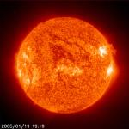
Food chains.
All food chains begin with the ……….

Plants use the sun to …………………

They make the energy in a food chain and are called ……………..

Some animals eat plants, they are called ………………..

Some animals eat other animals, they are called …………….

Animals that are hunted and eaten are called ………..

Animals that hunt and eat meat are called …………….
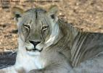
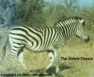

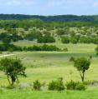
Sun herbivores
predators producers
grow carnivores
prey

Cut and stick the pictures to show a food chain.

