**Hatched or born?**

**Can you add some more animals to the table?**

|  |  |
| --- | --- |
| **Hatched** | **Born** |
| **chicken** | **kitten** |

**C:\Users\Emma\AppData\Local\Microsoft\Windows\Temporary Internet Files\Content.IE5\1YSGWAL6\MC900359833[1].wmf 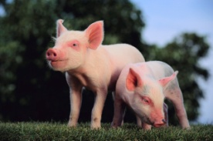 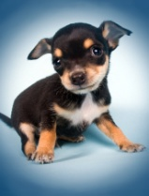 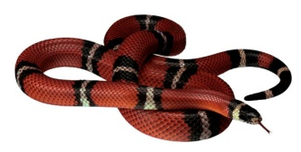 C:\Users\Emma\AppData\Local\Microsoft\Windows\Temporary Internet Files\Content.IE5\1YSGWAL6\MC900446200[1].wmf**

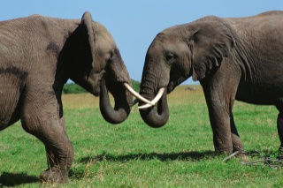 **C:\Program Files (x86)\Microsoft Office\MEDIA\CAGCAT10\j0186348.wmf C:\Users\Emma\AppData\Local\Microsoft\Windows\Temporary Internet Files\Content.IE5\1YSGWAL6\MC900013242[1].wmf C:\Users\Emma\AppData\Local\Microsoft\Windows\Temporary Internet Files\Content.IE5\YEN5FU5M\MC900186210[1].wmf**

**Can you add some more?**