L.O. To make observations and comparisons of height
To make predictions about and discuss the relationship between getting older and getting taller

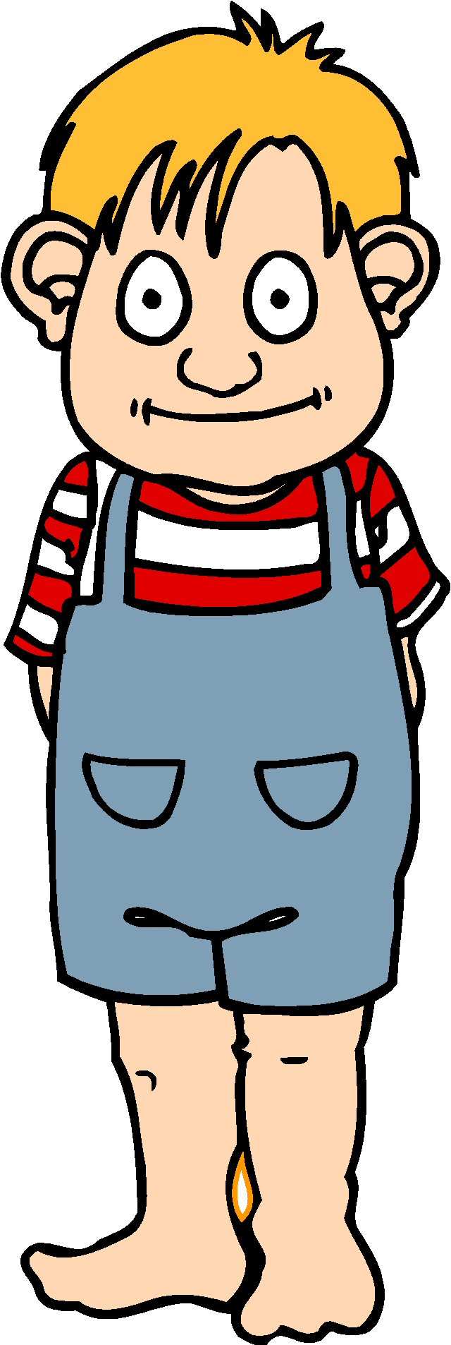
We lined up in order from tallest to shortest.
The tallest people in our class are:

We lined up in order from oldest to youngest.
The oldest people in our class are:

What did I learn from our investigation?

