Are our hands and feet
all the same size?

Which hand and foot
do we use most?

Are our eyes good
at measuring?
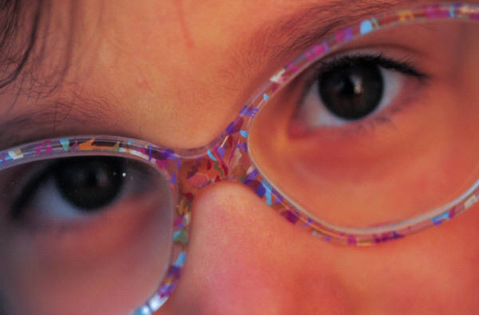

What do snails eat?

Is a sycamore seed better at dispersing when compared with a conker?

Which mini green house is
best for growing plants?
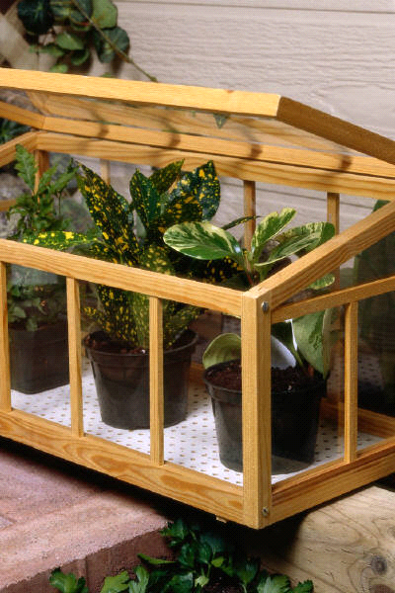

Which type of mat is best
at keeping tea warm?

Which car travels
furthest?

Which ear protector
is best?

Which torch is the
brightest?

Which object can be
catapulted the furthest?

Which ball is the
bounciest?

Which car is best
at going uphill?

How far can you
squirt water?

How well can people see?

Which is the strongest
magnet?

Which liquid washes
stains out best?

Which sponge is the
best for mopping up spills?

Which is the best
bubble mixture?

Find the best way of
drying wet fabrics.

Which bag is strongest?

Which bag is most
waterproof?

Does stirring make a difference
to how quickly a jelly sets?

Would baby bear’s porridge
really cool down first?

How good are people
at judging temperatures?

Can seeds grow anywhere?



Do shoots always grow up and roots always grow down?

Which is the best glue?

Which paper is best for
wrapping up a present?

Do people grow at
the same rate?


