Can you think of all the things we have to keep clean? KEEPING CLEAN
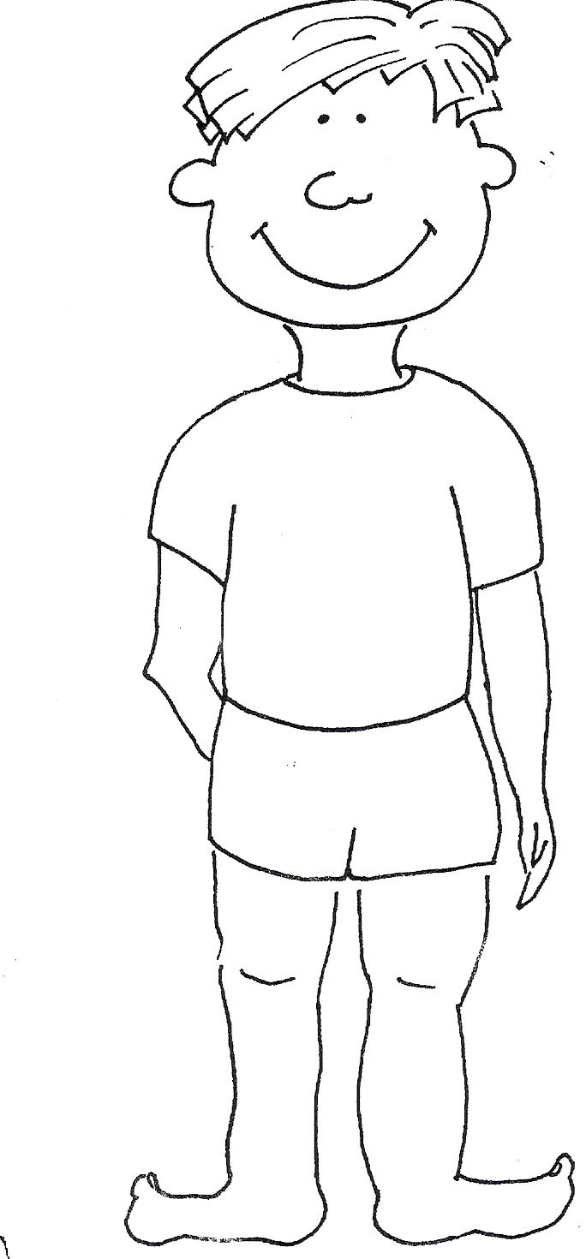
How often do you:

Wash your hair?

Everyday Morning and Night Twice a week Once a week
Brush your teeth? 

Everyday Morning and Night Twice a week Once a week

Have a shower?

Everyday Morning and Night Twice a week Once a week

Change your clothes?

Everyday Morning and Night Twice a week Once a week

Wash your hands?

Everyday Morning and Night Twice a week Once a week

Wash your face?

Everyday Morning and Night Twice a week Once a week
Change your socks?

Everyday Morning and Night Twice a week Once a week

Can you think of any others?
………………………………………………………………………………………………………………………………………………………………………………………………………………………………………………………………………………

