Name__________________ Date_____________
L.O. To know the difference between reflectors and sources of light.
Task: Cut out the pictures and stick them in the correct side of the table; Light sources or reflectors.
Light sources | Reflectors

----------------------------------------------------------------------------------------
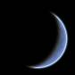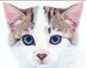
candle moon sun mirror safety jacket cat’s eyes
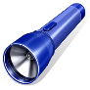
lamp disco ball torch

