Are they made from aluminum or steel?

Talk to your partner- what do you think?
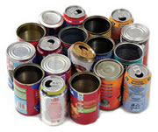

How many paper clips can you pick up with a magnet?

Talk to your partner- what do you think?
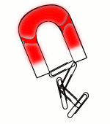

How quickly can you race the car around the track using only a magnet?

Talk to your partner- what do you think?
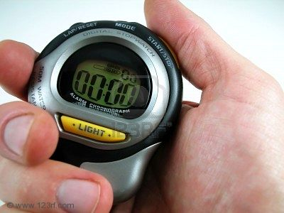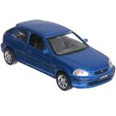

Can you find the magnetic treasure in the sunken ship?

Talk to your partner- what do you think?



Can you identify which objects are magnetic?

Talk to your partner- what do you think?

Sort the objects in magnetic and non-magnetic.

What happens if you put two magnets together?

Talk to your partner- what do you think?

north to south south to north

north to north south to south

