Can you match up the 5 senses?

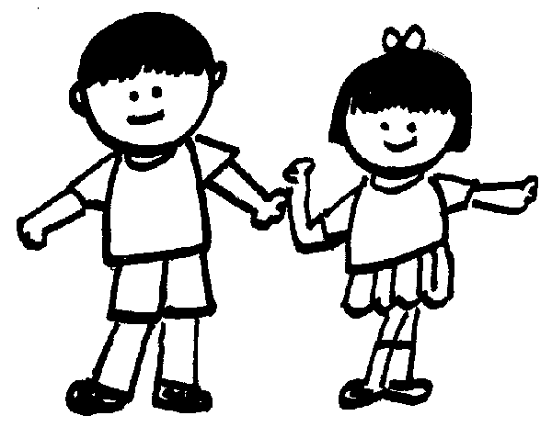
Draw a line to match up the name of the sense with its correct picture

Sight

TouchSee | 
TasteSee
SmellSee
Hearing

