Measuring forces using a Newton meter

We measure forces in Newtons (N) using a Newton meter.
A Newton meter is sometimes called a Force meter.

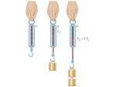

Task:

Your task is to measure the force (N) of different objects in the classroom. Copy the table below into your science book and record your findings.

(It may help if you use an elastic band to attach the object to the Newton meter).

NAME OF OBJECT | FORCE (N)

