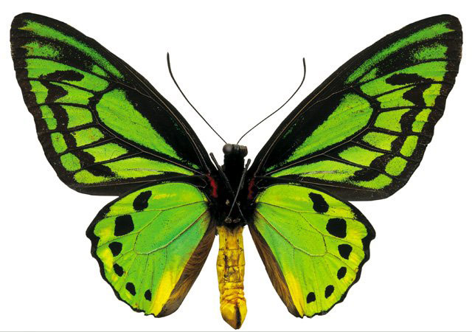
X C R A H D K O S C G J L Z Q E R Q A T S M M Y C P H L O X C C N N C
Huge Nature Wordsearch!
ASH
BADGER
BAT
BEECH
BEETLE
BERRIES
BLACKBIRD
BLUEBELL
BLUE TIT
BRACKEN
BRAMBLE
BUTTERFLY
CACTUS
CANDYTUFT
CATERPILLAR
CEDAR
CHAFFINCH
CHERRY
COLLARED DOVE
CONIFER
CORNFLOWER
DAFFODIL
DAHLIA
DAISY
DAYLILLY
DELPHINIUM
DORMOUSE
EARTHWORM
FIELDS
FIR
FORGET ME NOT
FOX
FOXGLOVE
FROG
GERANIUM
GLADIOLUS
HARE
HAWTHORN
HEATHER
HEDGEHOG
HEDGEROWS
HOLLYHOCK
HONESTY
HYACINTH
INSECTS

IRIS
JADE
JASMINE
JUNEBERRY
LARCH
LAVENDER
LILAC
LILY
LUPIN
MAPLE
MARIGOLD
MONKEY PUZZLE TREE
MOTH
OAK
PANSY
PETUNIA
PHLOX
PINE
POPLAR
POPPY
PRIMROSE
RABBIT
ROBIN
ROSE
SAGE
SILVERBIRCH
SLUG
SNAIL
SPARROW
SPIDER
SQUIRREL
STARLING
SWEET PEA
TADPOLE
TREES
TULIP
VIOLET
WALNUT TREE
WILLOW
WITCH HAZEL
WOODLAND
WOODLOUSE
WOODPIGEON
WREN
YEW
E L O P D A T B E U R M C H E R R Y A O I R C U U A Q E L P A M E G E
O U S V J X L L L J H R F R Z H L Z T Z L O L R I V N P G T C K K N D
X E E R L U T S Y H A W T H O R N D F R V W D K A N Y D E X T D C I A
L A F A E E X G J H Q E N N B V R E C D E H U W G L I R Y G U Z A L R
B S R B E Y X Y C O L L A R E D D O V E R T K E L X P H S T S E R R F
H C E B S M H E E Z A I L H A D L Z G P B R V F H I B O P E U D B A M
H L X N H E J Y Z J C O N I F E R I R L I A G A L Y D L P L I F A T O
L R A S A W F U U B U T T E R F L Y D S R E L L G D A O U T E R T S R
U P Q T I M P N T U S C E R N I R I S K C O A R L C R C R E H D R D U
T J H L S Y E I M P X S I F P I Q P I Y H R H E A V H I I M T A J E Y
M E L E E B B U O O U U H C Q B B V U L E W S D D T I A B N O I R V B
R O E K E B I P F O Q H E D G E H O G E V W A I I L U O F K T U T E K
W R N R A N P U L S E G A S A Y N G R Z O O K P O I W L L F C H S W H
T O R R A Y Y D C N V R J Q T V K L R A L O I S L A M K I E I A V E E
M Y I R I U O F B R E W O L F N R O C H G D N W U N L S G P T N L I D
Y V E G M O F V C E R D T G A U B S V H X L S Y S S E C T A Q I C B G
F G V K W T Q K B V N K L H F K U X G C O A E U F B P K E U L O W H E
X O K C O H Y L L O H I S O U K T X C T F N C C Y W Z E J Y T X P J R
E M R U R F T W Y B A T P V G S R G N I E D T X X U R L C K C N G P O
B A D G E R X E P H R Y X G H I Y X Y W N H S L V T L B R Q C X R M W
Q H C E E B W I B W Y I N H T V R L I E E I L R T U A M Q P G I B S S
G W A Q B T C H P D D T Z Y D K R A L O N K M U X I V A W B M L P X U
P E F R S V M N C R L I D O F F A D M I K I N O Y E E R F R C A H M Z
J D A E P T E E W S A I N U T E P O S D L L M T D J N B O I R A D Y Z
N A J Z F D E F N W O O D P I G E O N F A Y S S B I D S V R E G L L Z
I V D X R A X Q A O W J E M M Z H R K W W E A F A N E J O N R L T I B
P N E E O I M O T H T Q U S X W R I F B N C K D S J R W W E C M D L L
U R M W G S X U V W U Q D R M O R M C O T D F U M C G C M R P P X S S
L Z D J K Y E G D Y Z P Z T S I M Q H C E B Y N G E R F U W A Z B F C
