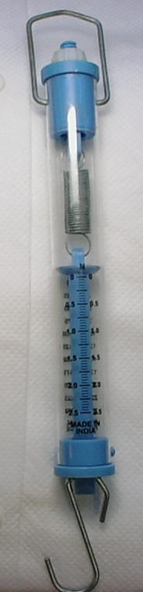
This newtonmeter measures forces up to 2.5 Newtons.
The numbered marks measure in 0.5N, the larger lines are 0.25 N and each smaller line is 0.05N.
You should not use this to try and lift anything that weighs more than 250 grams.
You measure from where this marker is on the scale.
If the marker were here, this would measure 2 N of force.

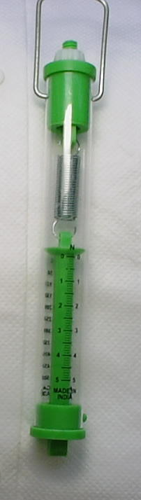
This newtonmeter measures forces up to 5 Newtons.
The numbered marks measure in 1N, the larger lines are 0.5 N and each smaller line is 0.1N.
You should not use this to try and lift anything that weighs more than 500 grams.
You measure from where this marker is on the scale.
If the marker were here, this would measure 3 N of force.

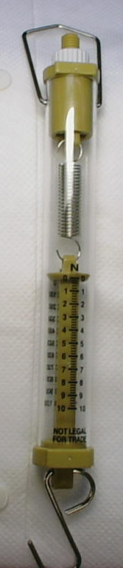
This newtonmeter measures forces up to 10 Newtons.
The numbered marks measure in 1N, each smaller line is 0.2N.
You should not use this to try and lift anything that weighs more than 1 kg.
You measure from where this marker is on the scale.
If the marker were here, this would measure 6 N of force.

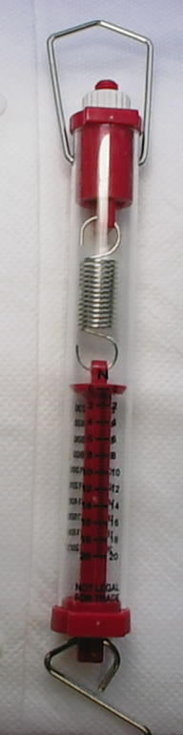
This newtonmeter measures forces up to 20 Newtons.
The numbered marks measure in 2N, each smaller line is 0.4N.
You should not use this to try and lift anything that weighs more than 2 kg.
You measure from where this marker is on the scale.
If the marker were here, this would measure 14 N of force.
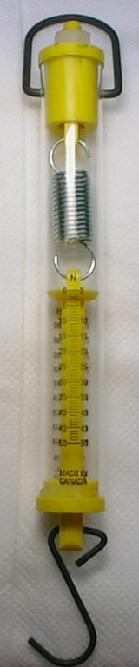
This newtonmeter measures forces up to 50 Newtons.
The numbered marks measure in 5N, each smaller line is 1N.
You should not use this to try and lift anything that weighs more than 5 kg.
You measure from where this marker is on the scale.
If the marker were here, this would measure 10 N of force.

