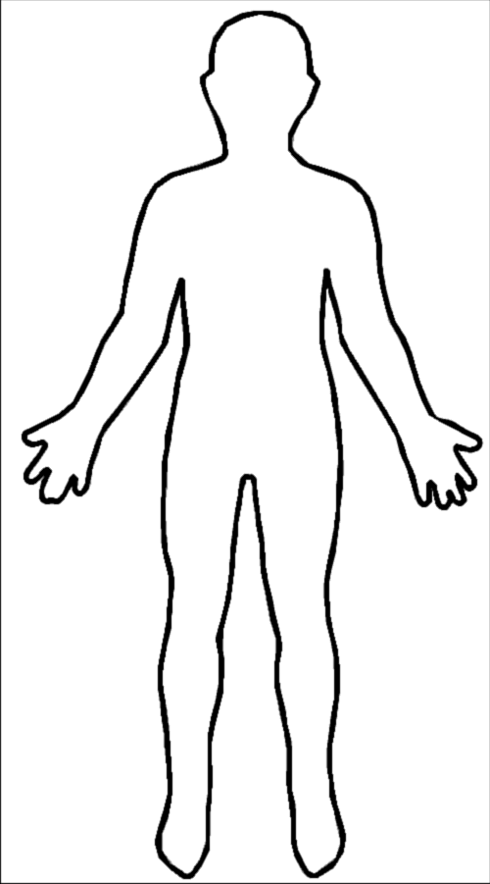
Parts of the body
Label the parts of the body.

- Cut the picture out (along the dotted line)

- Glue it into the middle of your page.

- Label the picture using the words below.

- Remember to use a ruler to draw the arrows pointing at the picture.

Parts of the body

- Head
- Leg
- Hand
- Arm
- Foot
- Stomach
- Shoulder
- Knee
- Ankle
- Neck
- Ear
- Mouth
- Nose
- Elbow
- Toe
- Finger
Remember to use a pen to write in joined up cursive writing! You may get a credit for presentation.

