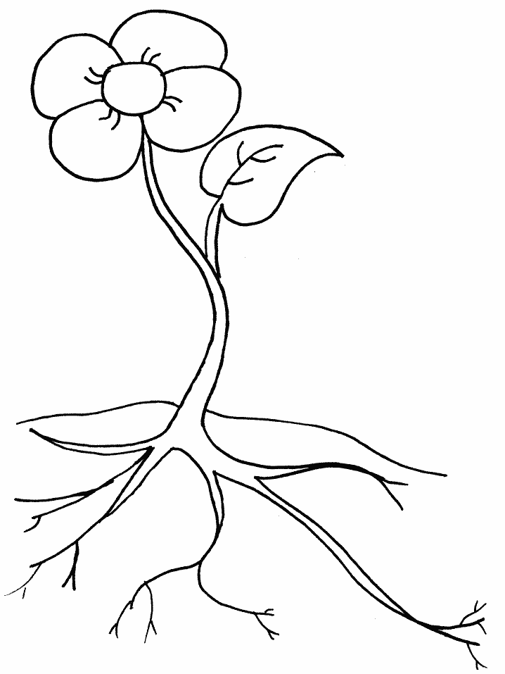
LI: To Label a plant

petal leaf flower stem root

