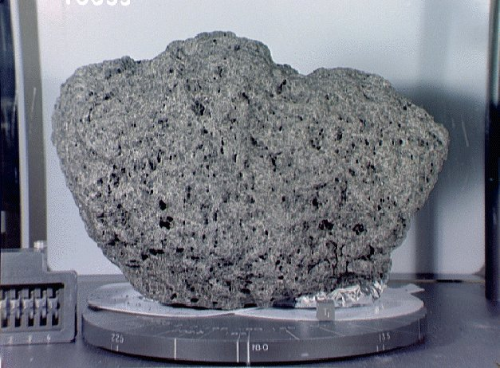
Notes
Basalt
I Spy for 20

Sedimentary Igneous Metamorphic
I Spy Rocks I Spy Minerals I Spy Rocks
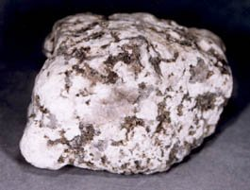
Notes
Granite
I Spy for 30

Sedimentary Igneous Metamorphic
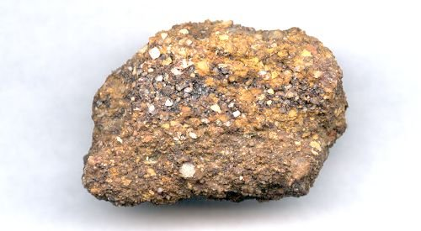
Notes
Sandstone
I Spy for 10

Sedimentary Igneous Metamorphic
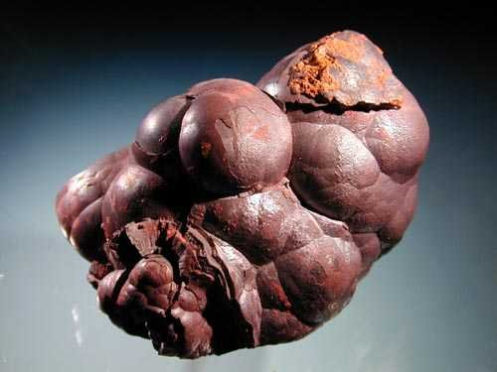
Gold (Mineral)
I Spy for 50
Notes
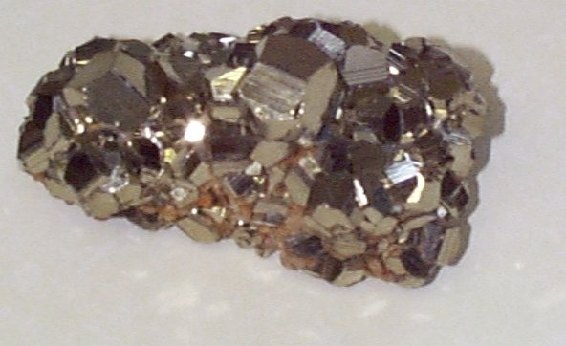
Pyrite - Fool's Gold
I Spy for 20
Notes
(Mineral)
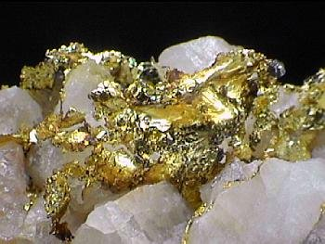
Basalt
I Spy for 20
Basalt
I Spy for 20
Haematite (Mineral)
I Spy for 30
Notes
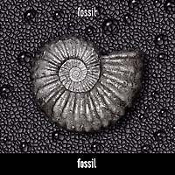
A Fossil
I Spy for 20
Notes

