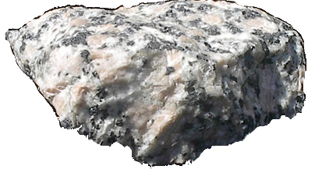
Name_____________________________ Date ___________________________________
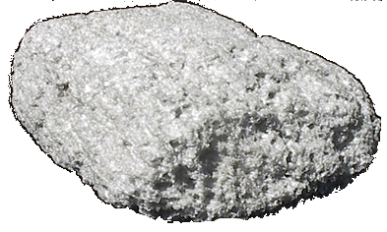
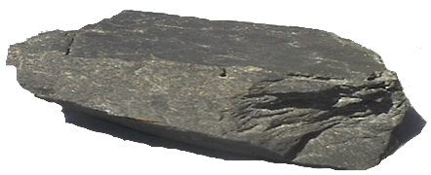

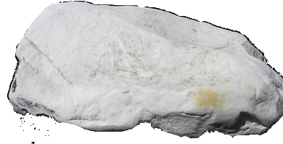

Rocks are strong and hard and they are good for building things, but are they all as durable as each other?

Durability means ________________________________________________

Hypothesis
I think that ________________________________ will be the most durable rock.
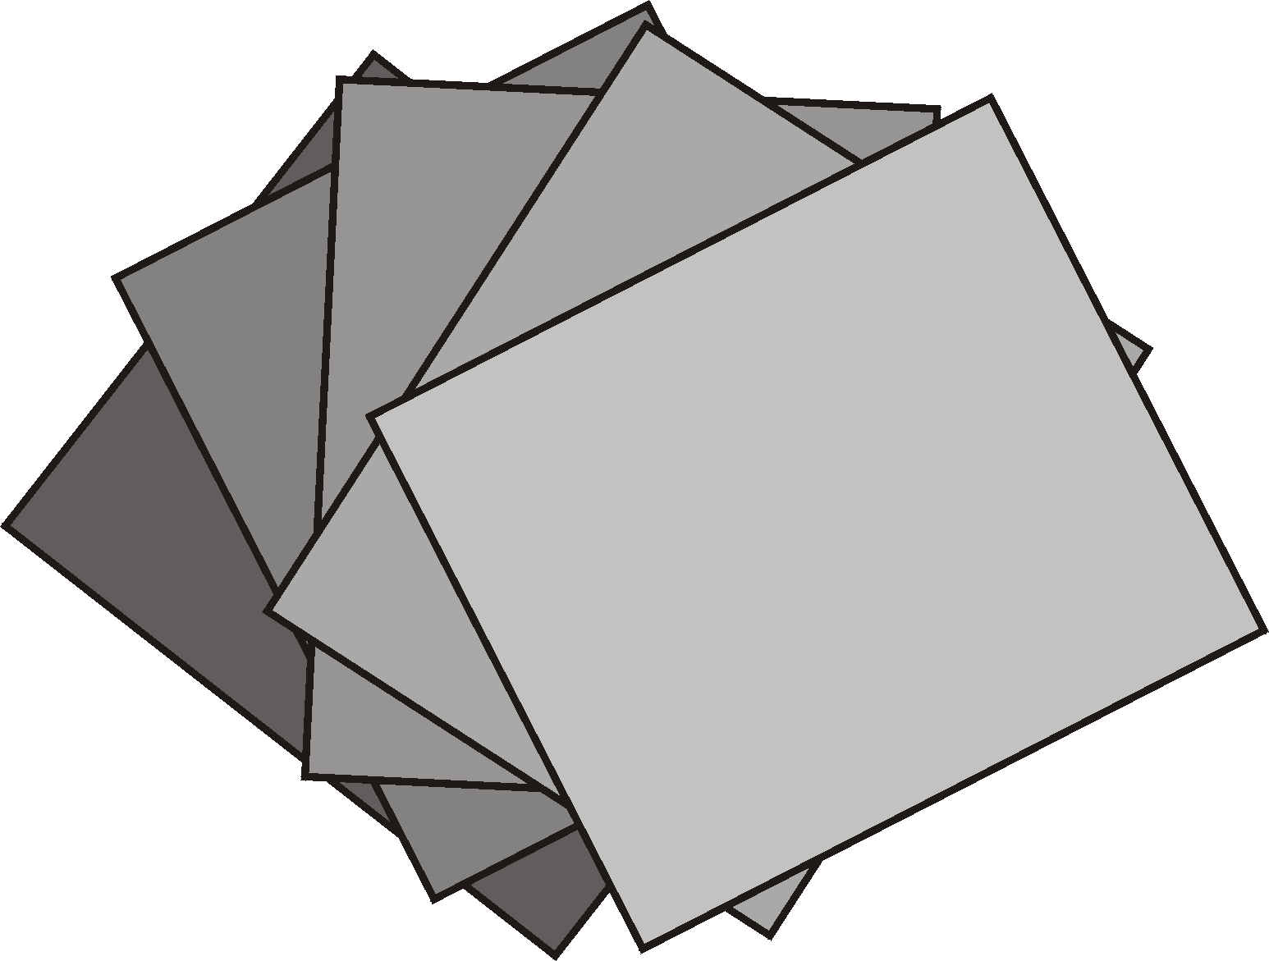
Method
We rubbed each rock with sandpaper and watched what happened

Results
Fill in this table with the things you noticed
ROCK | WHAT I NOTICED

The test was fair/unfair because ______________________________________
_____________________________________________________________

From our results, the most durable rock is ________________________________ because _______________________________________________________

From our results, the least durable rock is ________________________________ because________________________________________________________

