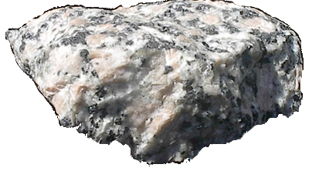
Name_____________________________ Date ___________________________________
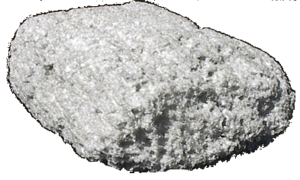
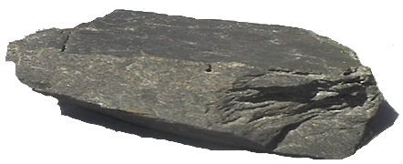

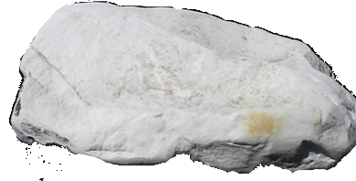

We use rocks are outside for buildings and things, but do they all keep water out or are some permeable?

Permeability means ________________________________________________

Hypothesis

I think that ________________________________ will be the most permeable rock.

Method
We dropped water onto each rock and watched what happened

Results
Fill in this table with the things you noticed
ROCK | WHAT I NOTICED

The test was fair/unfair because ______________________________________
_____________________________________________________________

From our results, the most permeable rock is ______________________________ because _______________________________________________________

From our results, the least permeable rock is ______________________________ because________________________________________________________

Think about the results of both of our tests and try to answer these questions
If I were building steps outside, __________________ would be the best rock because _______________________________________________________.

The worst rock to use would be _________________ because ________________
_____________________________________________________________

