Name Date Group 1
Using my senses around our school.
My eyes help me to . My ears help me to .

Write down things you can ............... Write down things you can ...............

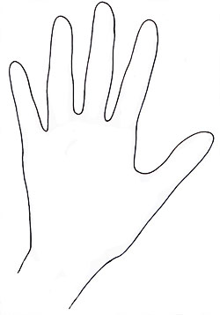
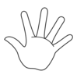

My nose helps me to . My mouth helps me to .
Write down things you can ............... Write down thing that you can ..................

My hands help me to .
Write down how different things .....................
Name Date Group 2
Using my senses around our school.
My eyes help me to see. My ears help me to hear.
Write down things you can see. Write down things you can hear.

My nose helps me to smell. My mouth helps me to taste.
Write down things you can smell. Write down thing that you can taste.

My hands help me to feel.
Write down how different things feel.

