Name………………………..
SKELETON WORKSHEET
- What is a skeleton? ________________________________________________
2. What would happen if we had no bones?
____________________________________________________
3. How many bones are there in the human body? _____________________________________________________
4. What is the bone in our head called? _____________________________________________________
5. What does this protect? _____________________________________________________
6. What do our ribs protect? _____________________________________________________
7. Which part of a bone is hard? _____________________________________________________
8. What is the inside of a bone called? _____________________________________________________
9. What is another name for the backbone? _____________________________________________________
10. Which of our bones make a sort of cage? _____________________________________________________

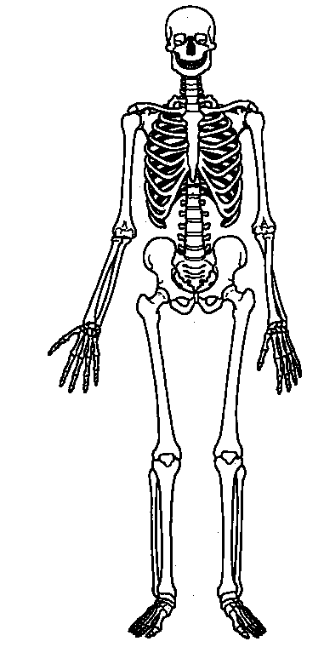
How many bones can you remember?
Label all the bones you can remember from the lessons this week.
If you get stuck use information books or the internet to help you.

