WALT: Label the types of teeth in the human mouth.

Humans are omnivores which means we eat meat and vegetation.

Humans have:
Canines for piercing
Molars for crushing & grinding
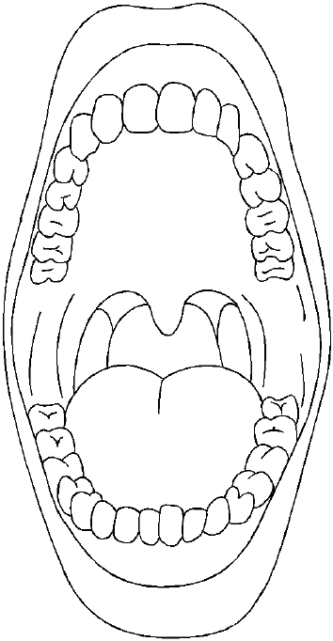
Pre-molars for crushing & grinding
Incisors for cutting

Colour the...
Canines- blue
Incisors- red
Pre-molars- orange
Molars- green

