Name__________________ Date______________________
Temperature Investigation 1

Look at the bowls of water. Predict the temperature for each bowl.

Iced water | 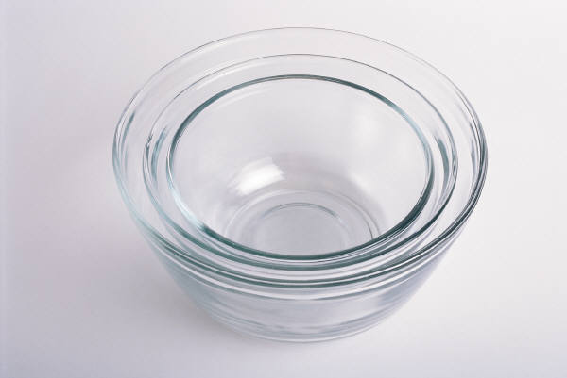  Room temperature |   Hand hot

Now using a thermometer and take the actual temperature of each bowl of water. How close were you with your prediction?

Iced water | Room temperature | Hand hot
At the end of the session take the temperature again.
Iced water | Room temperature | Hand hot

What has happened to the temperature in each bowl?

___________________________________________
Why?______________________________________

