Name: ________________________________

hear with my __________________.

smell with my _____________.

see with my ____________.

taste with my ____________.

feel with my ___________.

---------------------------------------------
ears hands tongue eyes nose

Can you match up the 5 senses?

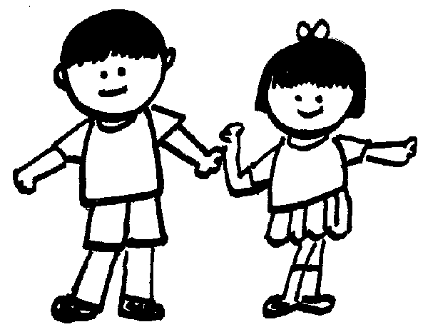
Cut out and match the word with the body part.

Sight

TouchSee | 
TasteSee
Hear
ee
SmellSee
Hearing

The Five Senses

We use our eyes to ___________.

We use our hands to ____________.

We use our ears to _____________.

We use our nose to _____________.

We use our tongue to _____________.

Use these words to help you finish the sentences.

smell | taste | touch | hear | see

