1.  What are the 3 states of matter? | 2.  What is happening to this ice cube? 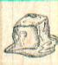 | 3.  liquid > solid what is this change called?
4.  Which state(s) of matter can you see here? 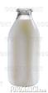 | 5.  What state of matter is petrol? | 6.  What makes an ice cube melt?
7.  What is the freezing point of water? | 8.  What does this symbol mean? | 9.  liquid > gas  what is this change called?
10.  Scientifically what is meant by melting? | 11.  Which state of matter is the cutlery? 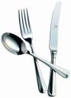 | 12.  What do we call the moisture on the window? 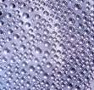
13.  What is the solid state of water called? | 14.  Scientifically what is meant by evaporating? | 15.  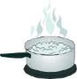 What is happening to the water?
16.  solid > liquid  what is this change called? | 17.  How would you change water into ice? | 18.  Which state of matter is runny?
19.  What is the gas state of water called? | 20.  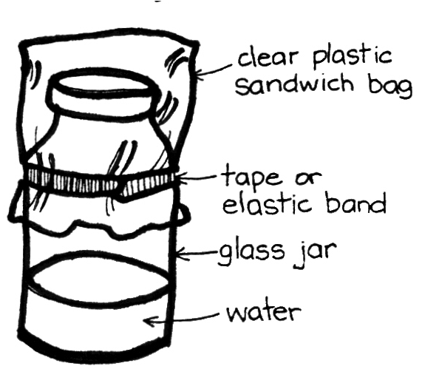What will appear in the bag? | 21.  What state of matter is water in at -15 ºC  (minus 15 ºC)
22.  If a beaker of water is left for a few days, what happens? | 23.  Scientifically what is meant by freezing? | 24.  What is coming out of the kettle? 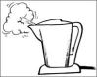
25.  Scientifically what is meant by condensing? | 26.  What are the tiny parts of material matter called? | 27.  What is the boiling point of water?
28.  What process is happening here? | 29.  gas > liquid  what is this change called? | 30.  What process is happening here?  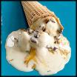

Treasure Hunt Year 5 Changing States
Name _______________________ Date_____________

1 | 2 | 3
4 | 5 | 6
7 | 8 | 9
10 | 11 | 12
13 | 14 | 15
16 | 17 | 18
19 | 20 | 21
22 | 23 | 24
25 | 26 | 27
28 | 29 | 30

Treasure Hunt Year 5 Changing States
Name _______________________ Date_____________

1  solid liquid and gas | 2  the ice cube is melting | 3  freezing or solidifying
4  solid glass, liquid milk and gas in air space | 5  liquid | 6  some form of heat
7  0 ºC | 8  reversible (reaction) | 9  evaporation or boiling
10  changing from solid to liquid | 11  solid | 12  condensation
13  ice | 14  changing from liquid to gas | 15  the water is boiling/evaporating/changing to steam
16  melting | 17  freeze it or cool it | 18  liquid
19  steam or water vapour | 20  condensation /water droplets | 21  solid
22  the water level goes down / it evaporates | 23  changing from liquid to solid | 24  steam
25  changing from gas to liquid | 26  particles (atoms or molecules) | 27  100 ºC
28  evaporation | 29  condensing | 30  melting

