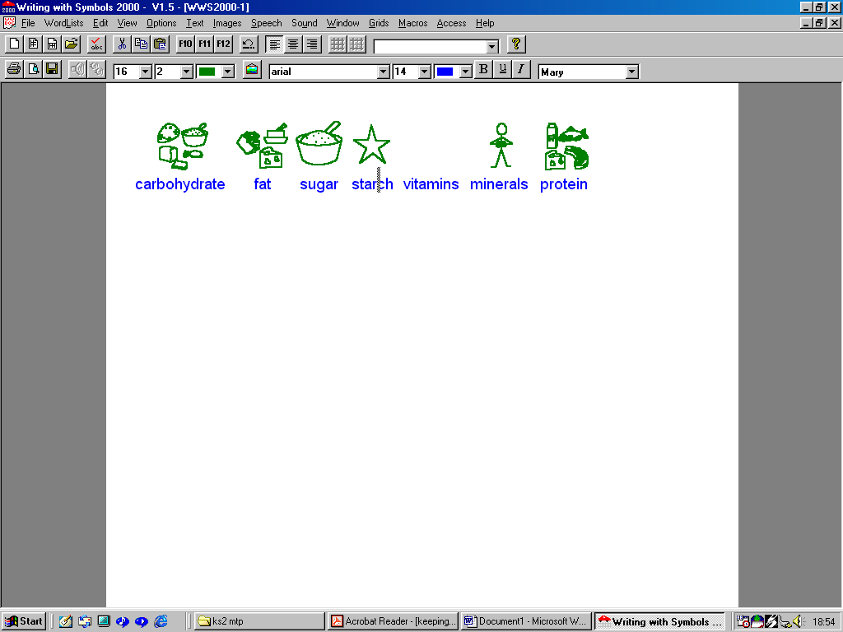
18/11/00 Created by Mark Laird modified by L.Chapman 18/1/01

Keeping Healthy – Food Name
You will need to look in a variety of books, leaflets and

What are the best food types for providing energy?
I think the best types of food for energy are .
One food type provides energy but, it is very important that you don’t eat too much of this food type. Why is this? .
Which food type helps you to grow? (This Type also helps your body to repair itself.)
I think is the type of food that helps me grow.

What do fruit and vegetables contain, and why are these healthy?
Fruit and vegetables have which I need to stay healthy.

What is provided by fruit and vegetables that helps food move through the gut?

Foods high in provide slow release energy, whereas foods high in provide quick release energy. and
are both .
Can you explain what might happen if you eat too much fat and sugar?

Remember to stay healthy we need
a varied and balanced diet.

Print this out and then on the back
Draw and label some foods that contain lots of fats and oils.

Draw and label some foods that contain lots of sugar and
starch.

