
Spend £10.00 Can you pay for your Christmas dinner?
CHRISTMAS DINNER

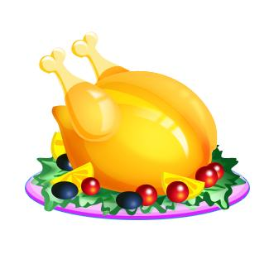



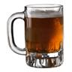
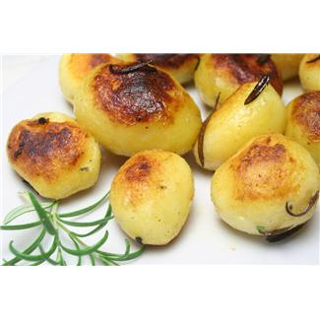


£1.10p
£2.45p
£1.00
£2.18p
52p
£2.22
£1.24
£0.94
£1.00 = 100p
Add up all the items
– do you have enough?
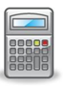
Thinking Skills
Which item could you not buy?
