
Spend £5.00
Can you pay for your Christmas dinner?
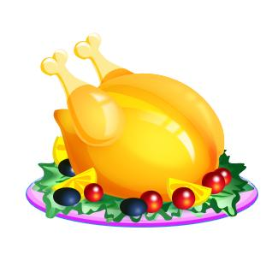



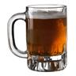
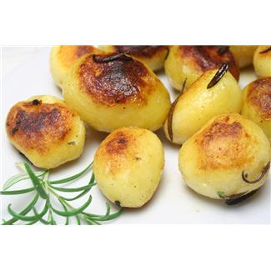


£0.95
£1.65
£0.40
£1.32
£0.52
£1.27
£1.13
£1.04
£1.00 = 100p
Add up all the items
– do you have enough?
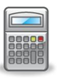
Thinking Skills
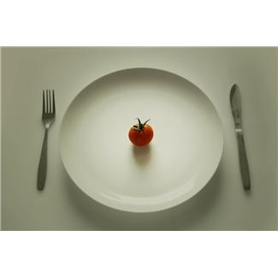
CHRISTMAS DINNER

