The Nightmare Just Before Christmas
It was another bitterly cold and frosty December night in the North Pole. A frozen blanket of snow lay deep and crisp on the ground. Jack Frost had visited every home and had etched magnificent spiral patterns into every glass window. It really was the harshest weather that anyone could ever remember and it was two days until Christmas!

Santa Claus was extremely busy adding the finishing touches to his Christmas preparations. He was shortly about to deliver thousands of wonderful Christmas presents to many excited children from all over the world. His elves were beginning to load masses of shiny gifts onto his sleigh and his brave reindeer were practicing their final manoeuvres before the big day. Everything was coming together nicely; Santa was very pleased with his team.

Creative task for this week.
Discuss the possible scenarios that could cause a problem that could ruin Christmas and then choose one to write about. Also consider how the nightmare could be stopped so the ending is a happy one! Some ideas are shown below.

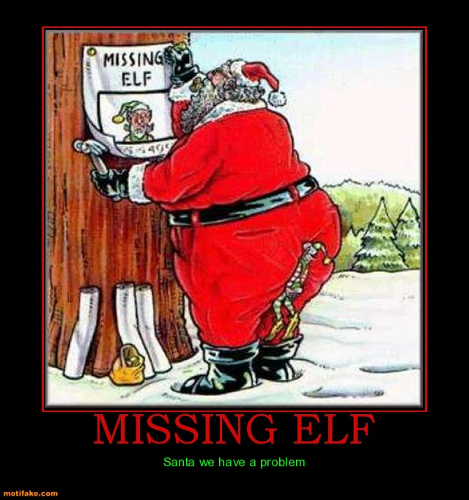
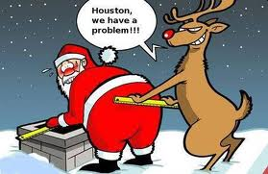

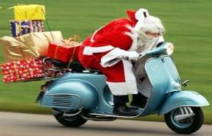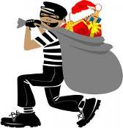
(Scroll down for planning sheet…)
STORY PLAN –The Nightmare Just Before Christmas
WOW WORDS (Include all in your best copy)

____________________________________________________________________________________________________________________________________________________________________________________________________________________________________________________________________________

OPENING
____________________________________________________________________________________________________________________________________________________________________________________________________________________________________________________________________

MAIN EVENTS
_______________________________________________________________________________________________________________________________________________________________________________________________________________________________________________________________________________________________________________________________________________________________________________________________________________________________________________________________________________________________________________________________________________________________________________________________________

ENDING (solution)
____________________________________________________________________________________________________________________________________________________________________________________________________________________________________________________________________

THE PROBLEM
____________________________________________________________________________________________________________________________________________________________________________________________________________________________________________________________________

