 | Name (supplier): | Function: | Who would use it?
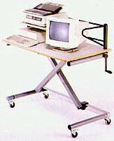 | Height-adjustable trolley (Inclusive Technology, SIS Jensen) | Allows precise adjustment, via a handle, of a computer to the correct height - even when fully loaded with equipment. | Users who use a wheelchair.
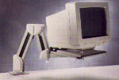 | Adjustable keyboard and monitor arms (Misco) | Attaches to a table and swings out to the correct height. | Users who use a wheelchair.
 | Footrests (Misco) | If the user’s feet are dangling down from a seat that is too high they can help to maintain sitting balance and achieve good hand control. | Users who have short legs!
 | Wristrests (Misco) | Stabilises the arm. | Users who require some wrist support - but do not need full arm support.
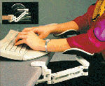 | Arm supports (QED) | Take the weight of the arm and let the user move across the keyboard to access the keys. | Users with a muscular weakness who get tired typing.

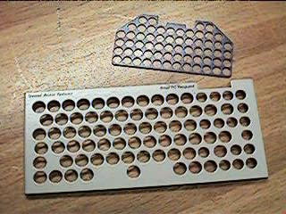 | Keyguards (Inclusive Technology) | It fits over the keyboard to help prevent unintentional keypresses. | Users who type with a finger or typing tool.
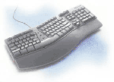 | Ergonomic keyboards (Misco) | Reduce the discomfort from injuries related to excessive keyboard use (wristrests are often built in as well). | Users who have injuries related to excessive keyboard use e.g. RSI.  Users who have limited hand control.  Users who suffer pain when typing (e.g. arthritis).
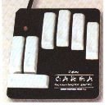 | Chording keyboards (KCS) | Have a handful of keys (one per digit per hand) to type by ‘chords’ which produce different letters and keys. | Users with the use of one arm.  Users with a visual impairment.  Users with limited arm range and strength.
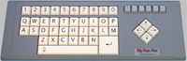 | Expanded keyboards (Inclusive Technology) | Keys are larger and more widely spaced. | Users who have difficulty with the small keys on a standard keyboard.
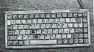 | Compact and miniature keyboards (Inclusive Technology, KCS) | A smaller version of the standard keyboard. | Users with limited range of movement who cannot reach across a standard keyboard.
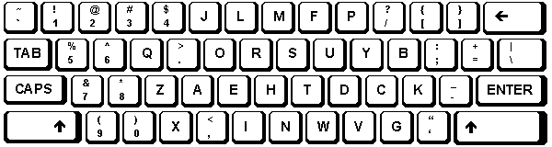 | Dvorak alternative keyboard layout - Microsoft Windows (Microsoft website) | An ergonomic keyboard layout, where the most common keys are located at either the left or right side of the keyboard. | Users with the use of one arm.

 | Software adaptations:
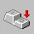 | StickyKeys - Accessibility Options, Microsoft Windows 95 onwards (Microsoft) | Allows characters or commands to be typed without having to hold down a modifier key (Shift, Ctrl, Alt) while pressing a second key. | Users who have difficulty pressing two keys simultaneously.
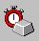 | FilterKeys - Accessibility Options, Microsoft Windows 95 onwards (Microsoft) | Instructs the keyboard to ignore brief or repeated keystrokes. | Users who have motor problems and who type using a finger.
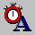 | FilterKeys (Ignore repeated keystrokes) - Accessibility Options, Microsoft Windows 95 onwards (Microsoft) | Adjusts the amount of time that elapses before a character repeats when you hold down a key. | Users who have motor problems and who type using a finger.
 | FilterKeys (Ignore quick keystrokes and slow down the repeat rate)  - Accessibility Options, Microsoft Windows 95 onwards (Microsoft) | Adjusts the speed at which a character repeats when you hold down a key. | Users who have motor problems and who type using a finger.
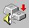 | ToggleKeys - Accessibility Options, Microsoft Windows 95 onwards (Microsoft) | A high sound is heard when the CAPS LOCK, SCROLL LOCK, or NUM LOCK key is switched on and a low sound is heard when any of those keys are switched off. | User who has difficulty knowing when a key has been pressed.  Users with a visual impairment.

- Suppliers

Name: | Address: | Telephone: | Website:
Inclusive Technology Ltd | Riverside Court, Huddersfield Road, Delph, Oldham OL3 5FZ | 01457 819790 | www.inclusive.co.uk
Keytools Ltd | PO Box 700, Southampton SO17 1LQ | 023 80584314 | www.keytools.com
Microsoft | Microsoft Limited, Microsoft Campus, Thames Valley Park, Reading RG6 1WG | 0870 6010100 | www.microsoft.com/uk
Misco | Darby Close, Park Farm South, Wellingborough, Northants NN8 6GS | 0870 7256990 | www.misco.co.uk
Quality Enabling Devices Ltd | Unit D16, Heritage Business Park, Heritage Way, Gosport, Hampshire PO12 4BG | 023 92580600 | www.qedltd.com

- Websites

CALL Centre, University of Edinburgh | www.callcentrescotland.org.uk
Empowering Technologies | www.emptech.info
Inclusive Technology Ltd (Articles on Special Needs and IT section) | www.inclusive.co.uk/infosite/index.shtml
Limbless Association | www.limbless-association.org
Microsoft Accessibility | www.microsoft.com/enable
NHS Direct Online | www.nhsdirect.nhs.uk
New Opportunities Fund (ICT Training) | www.inclusive.net
Typing Injury Frequently Asked Questions (USA) | www.tifaq.com

- Other

AbilityNet | AbilityNet Northwest, c/o AbilityNet Central England,  PO Box 94, Warwick, Warwickshire CV34 5WS | 0800 269545 (if calling from home) or 01926 312847 (if calling from work) | www.abilitynet.co.uk

