1. Unaided systems of communication (examples)

 | Name: | Function: | Who would use it?
 | British Sign Language (BSL) | A language of space and movement using the hands, body, face and head | Used by 70,000 deaf or hearing-impaired people in the UK, as well as 1,000s of hearing people.
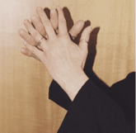 | Sign Supported English (SSE) | The use of BSL with an English grammar. | Used to enable people in the deaf community to learn and speak English.
 | Makaton | A combination of spoken words, sign language vocabulary, and graphic symbols. | Used by children and adults with learning disabilities.

2. Aided systems of communication

 | Name: | Function: | Who would use it?
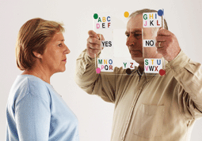 | Low tech | Simple paper or object based systems  (i.e. does not require a battery). | Users with limited or no clear speech.
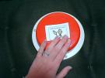 | Light tech | Simple voice output devices.  Battery operated. No sophisticated charging mechanism required. | Users with limited or no clear speech.
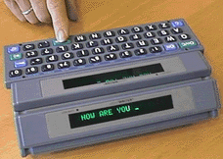 | High tech | Sophisticated voice output devices. Battery operated. Require training and ongoing support. | Users with limited or no clear speech.

- Suppliers

Name: | Address: | Telephone: | Website:
Crick Software Ltd | Crick House, Boarden Close, Moulton Park,  Northampton NN3 6LF | 01604 671691 | www.cricksoft.com
Dynavox Systems Ltd | Sunrise Medical Building, High Street, Wollaston, West Midlands DY8 4PS | 01384 446789 | www.dynavox.co.uk
Inclusive Technology Ltd | Riverside Court, Huddersfield Road, Delph, Oldham OL3 5FZ | 01457 819790 | www.inclusive.co.uk
PRI Liberator | PRI Liberator House, Minerva Business Park, Lynch Wood, Peterborough PE2 6FT | 0845 226 1144 | www.liberator.co.uk
Possum Controls Ltd | 8 Farmbrough Close, Stocklake Park Industrial Estate, Aylesbury, Buckinghamshire HP20 1DQ | 01296 461000 | www.possum.co.uk
Quality Enabling Devices Ltd | Unit D16, Heritage Business Park, Heritage Way, Gosport, Hampshire PO12 4BG | 023 92580600 | www.qedltd.com
TechCess Ltd | Unit 9, Willow Park, Upton Lane, Stoke Golding, Nuneaton, Warwickshire CV13 6EU | 01455 213708 | www.techcess.co.uk
Toby Churchill Ltd | 20 Panton Street, Cambridge CB2 1HP | 01223 576117 | www.toby-churchill.com
Winslow | Goyt Side Road, Chesterfield, Derbyshire S40 2PH | 0845 230 2777 | www.winslow-cat.com

- Websites

CALL Centre, University of Edinburgh | www.callcentrescotland.org.uk
Inclusive Technology Ltd (Articles on Special Needs and IT section) | www.inclusive.co.uk/infosite/index.shtml

- Other

AbilityNet | AbilityNet Northwest, c/o AbilityNet Central England, PO Box 94, Warwick, Warwickshire CV34 5WS | 0800 269545 (if calling from home) or 01926 312847 (if calling from work) | www.abilitynet.co.uk
ACE Centre North | Units 11 & 12 Gatehead Business Park, Delph, Saddleworth OL3 5DE | 01457 829444 | www.ace-north.org.uk
Communication Matters | c/o The ACE Centre, 92 Windmill Road, Oxford OX3 7DR | 0845 456 8211 | www.communicationmatters.org.uk

