11 |  |  |  |  | 1 |  |  | 2 |  |  | 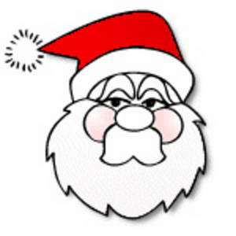  Down  1. ‘tis the season to be… (5)  2. there were three wise… (3)  3. He has a red breast (5)  5. Brings your 8 down! (5)  7. A good name for a snowman? (6)  8. Santa might leave some under your 11 down! (5)  9. Santa is always full of Christmas… (5)  10. Tie a ribbon in one of these. (3)  11. Put lights and baubles on this (4)
10 |  |  | 3 |  |  |  | 4 |  |  | 5
9 |  | 6
8
7 | 7 |  |  |  |  |  |  | 8
6
5 |  |  |  |  | 9 |  |  |  |  |  | 10
4 |  |  | 11 |  |  |  |  |  |  |  | Across  4. Another word for a big meal (5)  6. Spiky leaves and red berries (5)  7. They twinkle on the 11 down! (5,6)  12. You might have some for Christmas lunch (6)  13. Turns the world white (4)  14. He had a very shiny nose (7)
3 | 12 |  |  |  |  |  |  | 13
2
1 |  |  |  |  | 14
 | A | B | C | D | E | F | G | H | I | J | 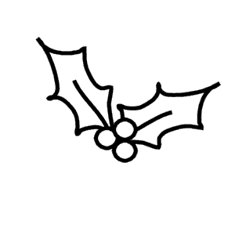  K

Christmas code Cracker!
Use your answers to crack the code and spell the secret message!

H11, E3, D7, C10, F3 E5, B9, E1, H6, H3, K10, H11, J6, K7
© M A Walter 2009

