 | World Wide Web   | 

1. Open Microsoft Internet Explorer: | 

2. Type the website address below into the Address box:
www.emailsanta.com

3. Click on the Go button or press the Enter key: | or 

4. Type in your first name and click on Click!: | 

5. Click on a stamp, such as Rudolph: | 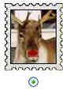

6. Choose whether you are a boy or girl and fill-in all the boxes: | 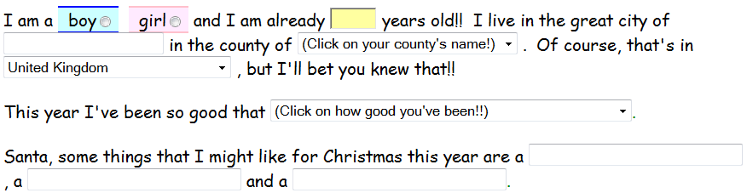

7. Click on a treat for Santa and his reindeer, such as Goodies to Eat: | 

8. Click on Send Santa Claus my letter!:

