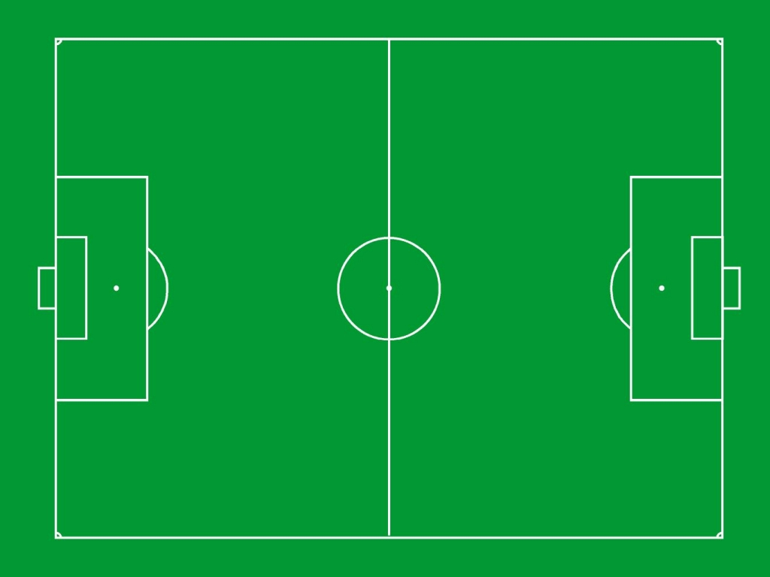

- How many rectangles are on the pitch?

- How many right-angles are in the pitch?

- How many lines of symmetry are there?

- How many circles can you see?

- What is the perimeter (Distance around) the pitch?

- What is the area of the pitch?

- What is the area of half the pitch?

- What is the perimeter of half the pitch?

- How far is it from the corner to the centre of the goals?

- Have you noticed anything else?

