 Catch the Culprit Day 

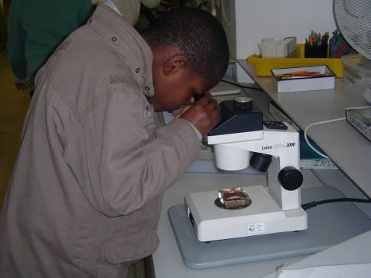

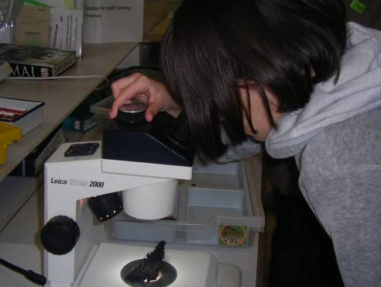
Preparation: before the day, collect newspaper cuttings and video clips of use of forensic science in solving real life crimes.

Examples of news paper headlines to collect:

Police find knife used in stabbing case

Couple jailed 21 years for child benefit claim fraud

TV Crime Watch program to release artist impression of Bow Street jewellery burglar

Hairs of victim found in suspect’s car boot

Police sieve through thousands of documents in Mayor Office fraud case

Family release cctv tape of the last moments of their son before his disappearance two months ago

Police comb forest in ‘Body in the Wood’ case

Family appeal for witnesses in fatal stabbing case

Bite marks found on dead victim’s neck and arms
Catch the Culprit Day

Design a logo for your forensic science laboratory.

Key questions:

- What message would you like to communicate with your logo?
- Who are your target audience?
- How will you make your logo stand out from others?
- What elements will you include to show it is a forensic science logo?

Collect different logos and emblems to discuss as a class
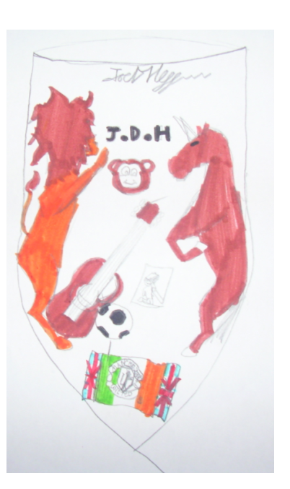
What does this logo show? How could you improve on it to make it a more forensic science logo??
Catch The Culprit Day
CASE: “ _______________________”

Evidence _____________________________
_____________________________________
Scientist/s: ____________________________
Date of Analysis:_______________________
Time of analysis: _______________________

ANALYSIS OF EVIDENCE RESULT:

Description of crime scene evidence including any visible identifying features
____________________________________________________________________________________________________________________________________________________

ANALYSIS OF SUSPECTS’ SAMPLES:
SUSPECT | RESULT (positive / negative)
Note: write ‘positive’ result if the suspect’s evidence is incriminating

CONCLUSION:
Describe conclusions that can and cannot be drawn from the results:
______________________________________________________________________________________________________________________________________________________________________________________________________________________________________________________________________________________________________________________
Catch The Culprit Day
CASE: “Breakage at the Vicarage”

Evidence: Finger prints Suspect: _________________

Procedure: Roll each finger in turn over the ink pad and carefully roll it into the right box below

Right thumb | Right index  Finger | Right middle  finger | Right ring finger | Right little finger

Left thumb | Left index  Finger | Left middle  finger | Left ring finger | Left little finger

Complete this for each of the suspects. Examine each sample and compare with crime scene finger prints.

Which suspect’s finger prints match the crime scene prints?
Finger prints background knowledge

Finger prints for each person is unique. This is because our skin is made of two layers, an inner layer and an outer layer. The outer layer is made up of a series of ridges which form a unique pattern in each person. The inner or deeper layer contains sweat and oil glands plus the blood vessels and nerves cells.

Each time we touch a surface the oil and sweat from the deeper skin layer combine with dirt from our outer skin layer to form an impression of the ridges patterns on the surface leaving finger prints. This provides detectives with an infallible method of identifying people.

There are three distinct types of patterns in human finger prints. These are – the arch, the whorl and the loop but they are different in each person.

Arch patterns have lines that start at one side of the print rising towards the centre of the print and then leaving at the other side of the print.

Whorls have a lot of circles that do not leave either side of the print.

Loops have lines that start on one side of the print, rise towards the centre and leave the print on the same it started on.

Compare your collection of suspects’ finger prints with the crime scene evidence sample (get one person to give their finger prints twice for this). Students should be able to find the match, this is the culprit!

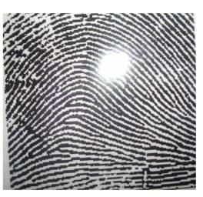Arch
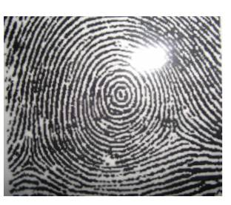Whorl
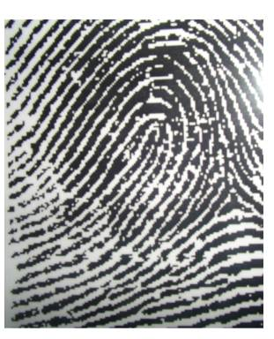Loop
Catch The Culprit Day
CASE: “The Ransom notes”

Evidence: The ransom note Suspects: handwriting exemplars

Procedure: Preparation
- Write a ransom note on a piece of paper.
- Write another sentence using handwriting suspect A sheet. (Example of sentence is included below).
- Get about six members of staff or students to write the same sentence out using the handwriting suspect sheets B, C, D, E , F, G, etc These are the handwriting exemplars.
- Students compare the handwriting exemplars with the ransom note to find the culprit.
Use the sheets below to take handwriting exemplars from suspects.

Ask students to look closely at:
  - The way the lines form the letters,
  - The slants of the letters; are these forward, backwards or straight up and down.
  - Have they used decorations or ornaments as circles or twirls?
  - How do they join or not join the letters?
  - How much space is there between the letters and between the words?
  - How do they cross their ‘t’s and dot their ‘i’s?

Record your observations here
suspect  sample | Size of letters | slant | Distinct style | Joins style | ‘t’ crossing | ‘i’  dotting | Word spacing | Letter spacing

How it works: Handwriting like fingerprinting contains characteristics which make them unique to individuals. Forensic scientists can usually work out whether or not the suspect is the culprit.

Handwriting analysis is used to solve forgery cases, to identify the writer of a letter or cheques etc. More recently it has been used to catch social benefit fraudsters who make multiple claims using different names and addresses or other details.
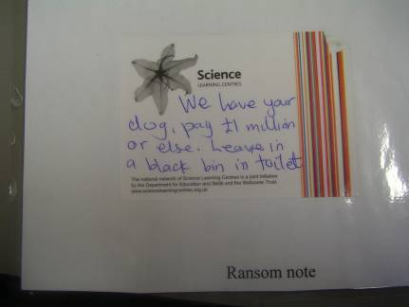

Compare the different handwritings
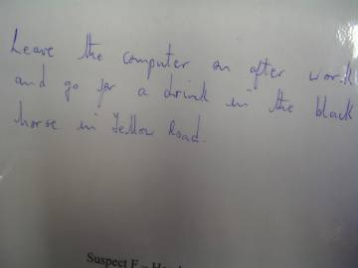

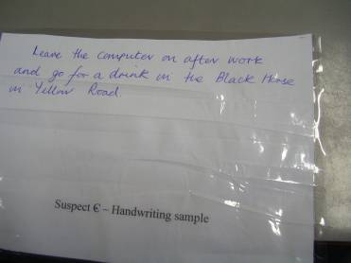
Catch The Culprit Day

Ransom note

Handwriting exemplar – suspect A

Catch The Culprit Day

Handwriting exemplar – suspect B

Handwriting exemplar – suspect C

Catch The Culprit Day

Handwriting exemplar – suspect D

Handwriting exemplar – suspect E

Catch The Culprit Day

Handwriting exemplar – suspect F

Handwriting exemplar – suspect G

Catch the Culprit Day
CASE: “ The Ransom notes”

Handwriting analysis sheet

Record your observations here (Describe or draw)

suspect  sample | Size of letters | slant | Distinct style | Joins style | ‘t’ crossing | ‘I’  dotting | Word spacing | Letter spacing
Crime scene

Which suspect handwriting match the ransom note?

Catch the Culprit Day
CASE: “The Fraud Scam”

Evidence: The fraudulent cheque
Suspects: ink samples from employees pens

Procedure: Preparation
- write out a cheque for a large sum of money, sign it
- collect several other black and blue pens
- Get different people to copy your signature above using the pens on pieces of coffee filter paper. You should also do one. Ensure that there is a blank space of about 3- 4mm at the bottom.
- Keep a record of pen type used for each writing piece.

Chromatography procedure:
- students carefully cut out a 3- 5 mm wide strip from each coffee paper containing the signatures
- Fold the strip over a pencil or thin paint brush and secure with sticky tape.
- Set up the chromatography apparatus by pouring a bottle of solvent e.g. surgical spirit into a pan.
- Hang the skewer (pencil or paint brush) over the solvent, so that the tips of the strips just touch the solvent. Do not get the ink wet.
- Set aside for 15 minutes for the ink to separate. The solvent will slowly rise up the filter paper to dissolve the ink, forming a banding pattern.
- The banding patterns will reveal which suspect’s pen was used to write the note.

How it works

Ink is a mixture of several dyes and when it is exposed to certain solvents, the colours separate. In a solvent, the ink spreads across the paper when it dissolves.

Ink can be water or alcohol soluble, when it dissolves in either, the resulting banding pattern of the components is called chromatography.

Task: Research cases where ink chromatography is used to solve crime.

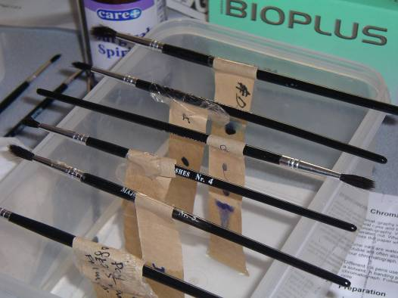

The result of the ink dissolving in the solvent will show unique banding pattern for each pen type as the ink separate differently in each case.

Catch the Culprit Day
CASE: “The Missing drink”

Evidence: crime scene drinking glass
Suspects: lip prints on drinking glasses

Procedure:
- Get several people’s lip prints on drinking glasses using bright lipstick. Put on some lip stick and imprint on the recording sheet (glass imprints tend to smudge after some time)
- Get one person to do this twice.
- Present students with the case notes and the necessary equipment and evidence to proceed.
- Provide students with the background information on lip prints to read (included with case notes sheets)
- They should then study each lip print and record their findings using the recording sheet below.
- They then compare the lip prints to find which matches the crime scene sample.

Analysis questions - Which lips have:

- Branching grooves

- Short vertical grooves

- Long vertical grooves

- Diamond grooves

- Rectangular grooves

Key question: which lip print matches the crime scene lip print?
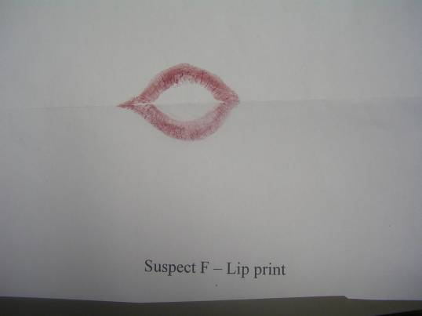

This lip print has long vertical grooves / short vertical grooves/ branching grooves. Which? Use a magnifying glass to find out.
Catch The Culprit Day

Suspect A lip print

Suspect B lip print

Catch The Culprit Day

Suspect C lip print

Suspect D lip print

Catch The Culprit Day

Suspect E lip print

Suspect F lip print

Lip Prints analysis sheet

Scientist ______________ Time: ________

Suspect | Diamond grooves | Rectangular grooves | Branching grooves | Short vertical grooves | Long vertical grooves
Crime scene

Suspect | Diamond grooves | Rectangular grooves | Branching grooves | Short vertical grooves | Long vertical grooves
Crime scene
Catch the Culprit Day
CASE: “A murder Mystery”

Evidence: coded letter

Procedure:
- Read through the letter below with the students, what message could it contain?
- Who uses coded messages? Where? When? How?
- How can we crack the code in this letter?
- What is the solution to the coded message contained in the letter?

Solution below

Dear Mr Lutkaz,

Layo has gone on a trip to Lapland with Eve, ((L e)
Although he was feeling poorly, he gave (a ve)
Tommy some instructions with (t h)
Extensive details on how to get to the top. (e p)
Annie tried to get some tic-tac (a c)
Kipling for Maria (k a)
Getting wet in the fruitless adventure, (g e)
If she does not give up by tomorrow (I w)
I will have to have to cancel the football (i l)
Getting to it is out of the question for Eve (g e)
Tommy will not be in to overreact. (t i t)

Leave the package, I will get it.

Catch the Culprit Day
CASE: “A Murder Mystery”

Suspect evidence: letter

Dear Mr Lutkaz,

Layo has gone on a trip to Lapland with Eve,
Although he was feeling poorly, he gave
Tommy some instructions with
Extensive details on how to get to the top.
Annie tried to get some tic-tac
Kipling for Maria,
Getting wet in the fruitless adventure,
If she does not give up by tomorrow,
I will have to have to cancel the football
Getting to it is out of the question for Eve
Tommy will not be in to over react.

Catch the Culprit Day
CASE: “Fake Silk”

Evidence: single thread from confiscated fabric

Samples: selection of different fabric

Procedure:
- Show and discuss silk fibre with the students. Give them opportunity to observe this closely under the microscope
- Show the students how to use tweezers to pick out a single fabric fibre from each material in turn.
- Student should observe each single thread fibre from each fabric in turn using the microscope
- Students can either draw and/or describe what they can see including distinctive features on their recording sheet.
- Discuss the differences in thickness, pattern, colour etc between each fabric fibre.
- Which fibre is the same as the silk fibre
- Students can research cases detectives have used cloth fibres left at the scene of a crime to convict a criminal. This could also include wig fibres cases.

Catch The Culprit Day
CASE: “ Fake Silk”

Evidence _____________________________
_____________________________________
Scientist/s: ____________________________
Date of Analysis:_______________________
Time of analysis: _______________________

ANALYSIS FABRIC SAMPLES:
Fabric | Features (describe or draw)

CONCLUSION:

______________________________________________________________________________________________________________________________________________________________________________________________________________________________________________________________________________________________________________________
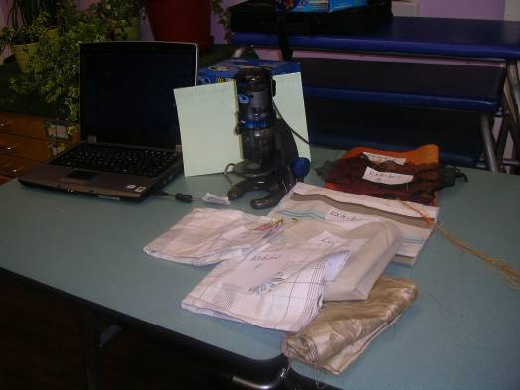

Catch the Culprit Day
CASE: “Suspect Likeness”

Procedure:
- Cut out a photograph of a person (your suspect) from a magazine or newspaper.
- Explain the case to the students
- Show them the photograph of the suspect for about 10 seconds. They should study this closely.
- Turn the picture face down and ask the students to draw the person from memory
- Their drawing should show what the suspect was wearing or holding and they must include all physical features they can remember. (You will be amazed at the result)
- After this they must write a suspect description for the police.
- Afterwards, discuss with the students how easy or difficult this task was and lead on to point out the difficulties faced by the police when they have to rely on witness description from memory of an incidence they saw very briefly.

Key questions: what features were easy to remember? Which were difficult and why?

The big question: what if all the evidence the police use to convict people are witness drawings or statements?
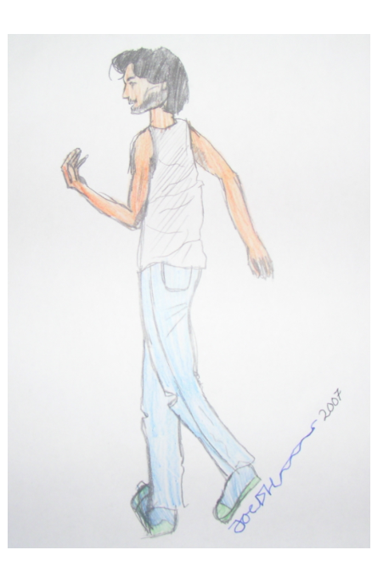

Look at this picture for 10 seconds. Now draw the suspect from memory. Include as much detail as you can.

Catch the Culprit Day
CASE: “The Missing Doughnut”

Crime scene evidence: Half eaten doughnut

Procedure:
- Get 6 doughnuts or hard dough bread
- Get six people to bite into each one, they must bite hard but not hard enough to cut off a piece, just enough to make bite marks.
- One person should bite into two pieces of doughnut.
- Put each beaten doughnut on a plate as evidence samples to be analysed.
- Students should read the bite marks background knowledge before proceeding
- Students should then observe the bite marks on each doughnut using magnifying glasses
- Students record their observations on the general recording sheet.

Key questions - which bite marks, have teeth that are:
  - Crooked
  - Have gap between front teeth
  - Slanted
  - Sharp fangs
  - Short
  - Long
  - Split or broken

Which bite marks match the crime scene bite marks?

Use the general analysis sheet to record your findings.

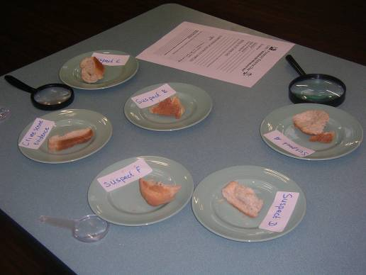

Catch The Culprit Day
CASE: “ Fence Damage”
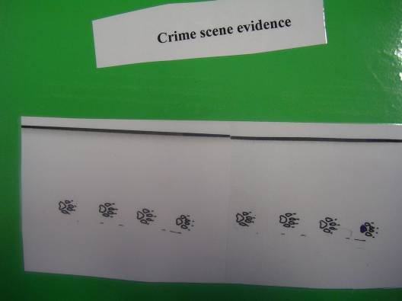
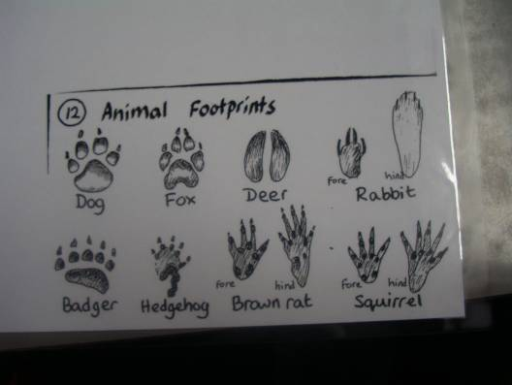
Compare suspects’ foot prints with crime scene evidence, who is guilty?
Catch The Culprit Day

CASE: “Evaluation of activities”

What did you learn from today’s work?

Which was your best activity? Why?

Did anything surprise you?

Could anything have been done differently? Why?

What will you definitely remember in the future?

Can you see yourself becoming a forensic scientist in the future?

What about a police officer or detective?

Perhaps a court judge or news reporter?

What do you think?

The justice scales



Now you have established the culprits, they must be put on trial but remember, their punishment must fit the crime.

The law must be fair and balanced!

