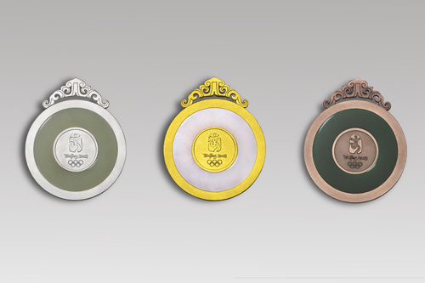
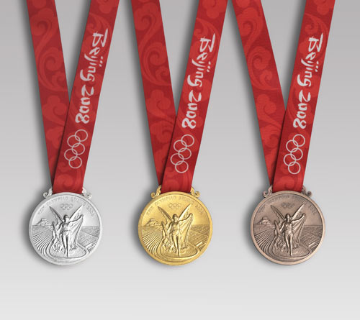
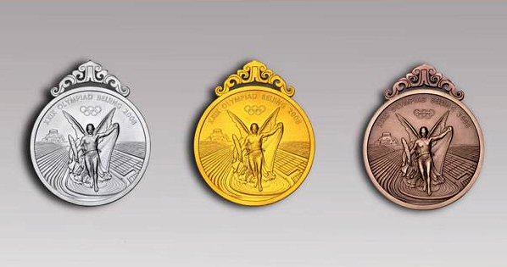
How must the Olympic medals be made?
Each Olympic medal must be at least 68mm across and 3mm thick. The gold and silver medals must contain at least 92.5% silver, and at least 6 grams of 24-carat gold must coat each gold medal. Bronze medals contain copper, zinc, tin and a very small amount of silver.

Design Features
Since 1928, the front side of every medal has featured a picture of Nike, the Greek goddess of victory. A new design was created for the 2004 Games, featuring the Greek Stadium and a new image of Nike. Based on a statue carved in 421 BC which was kept in the Temple of Zeus in Olympia, the new image shows Nike flying into the stadium as if to crown the winners with a wreath.

Reverse Side
The reverse side of every medal is unique to each Olympic Games and is designed by the host city. The medal for the Beijing 2008 Olympic Games has been inlaid with a jade disk, inspired by an ancient Chinese piece called "Bi". Jade has an important place in Chinese culture as it represents beauty and excellence in all things. The medal hook is inspired by the dragon which is a symbol of strength and power.

What size must the Olympic medals be?

Who is pictured on the front of the medal and what is she the goddess of?

What are bronze medals made from?

Jade is semi – precious stone. What does it represent?

5. The hook for the Beijing Medals represents which animal?

6. On the back of this sheet design your own Olympic medal. Use a pair of compasses to make it the correct size. Think about what pictures/words you might put on it.
Olympic Medals

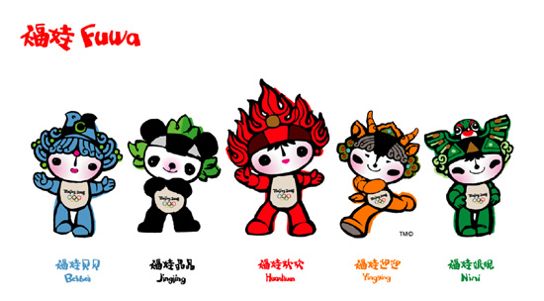
Olympic Mascots
Fuwa will serve as the Official Mascots of Beijing 2008 Olympic Games, carrying a message of friendship and peace -- and good wishes from China -- to children all over the world.
Fuwa represent four of China's most popular animals -- the Fish, the Panda, the Tibetan Antelope, the Swallow -- and the Olympic Flame. Each Mascot is one colour out of the 5 olympic rings.
Each of Fuwa has a rhyming two-syllable name -- a traditional way of expressing affection for children in China. Beibei is the Fish, Jingjing is the Panda, Huanhuan is the Olympic Flame, Yingying is the Tibetan Antelope and Nini is the Swallow.

2. Look carefully at the pictures. Try to work out which mascot represents which animal: Draw a line between them:

Beibei
Jingjing
Huanhuan
Yingying
Nini

Antelope
Olympic Flame
Panda
Fish
Swallow

Write down the first syllable of each of their names. They must be in the order of the pictures above.

_ _ _ / _ _ _ _ / _ _ _ _ / _ _ _ _ / _ _

This means “Welcome to Beijing” in Chinese. Practise saying it out loud!
3. On the back of this sheet draw your own mascot for your favourite sport. Start with a good animal to represent it.

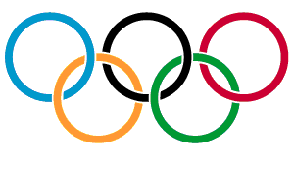
What is the meaning of the Olympic Rings?
The Olympic symbol consists of five interlaced rings of equal dimensions in five different colours, which are, from left to right, blue, yellow, black, green and red. The Olympic symbol represents the union of the five continents and the meeting of athletes from throughout the world at the Olympic Games.

Which 5 continents (out of the seven) do you think they mean?
1._______________ 2.______________
3._______________ 4. _____________
5._______________
2. Colour the Title at the top of this page in the 5 Olympic colours.

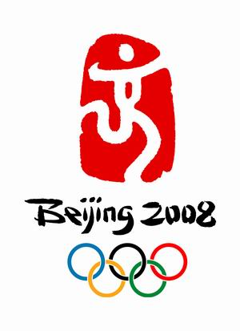
2008 – Beijing

“Dancing Beijing" is in a favorite color of the Chinese people. The color "red" is intensively used in the emblem, pushing the passion up to a new level. It carries Chinese people's longing for luck and happiness and their explanation of life.

http://en.beijing2008.cn/video/promotional/dancing/

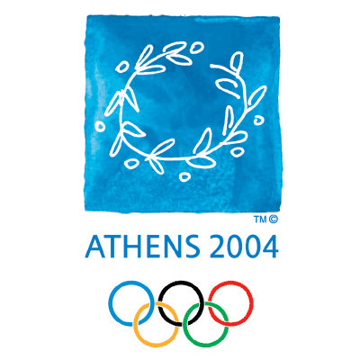
2004 – Athens

The 2004 Olympic Games emblem is a wreath made from an olive tree branch. The emblem is a reference to the ancient Olympic Games, where the olive headdress was the official award of Olympic champions. The colours of the emblem symbolise the shades of white and blue found in the Greek countryside.

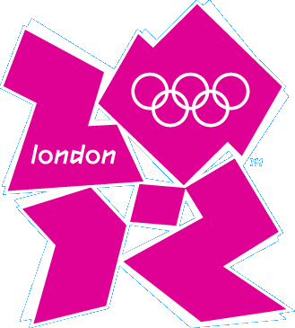
2012 – London
This Olympic emblem is based on the number 2012 -- the year of the Games - and includes the Olympic Rings, one of the world's most recognised brands, and the word 'London' -- the world’s most diverse city.
London 2012 will be Everyone's Games, everyone's 2012. This is the vision at the very heart of our emblem.

This emblem caused lots of controversy. Can you design a better one? Think about London. What would you put on the emblem?

Think about the type of qualities and chracteristics an athlete needs to have. Write these around him.

The Olympic Motto
A motto is a phrase which sums up a life philosophy or a code of conduct to follow.
The Olympic motto is made up of three Latin words: "Citius, Altius, Fortius", which means "Faster, Higher, Stronger".
These three words encourage the athlete to give his or her best during competition, and to view this effort as a victory in itself.
The sense of the motto is that being first is not necessarily a priority, but that giving one's best and striving for personal excellence is a worthwhile goal. It can apply equally to athletes and to each one of us.

My motto
Try to think up 3 words as your own personal motto for your life.

What do you want to do and be?
What kind of person are you?
How do you want to act?
How do you want others to think of you?

Pictograms
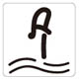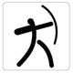

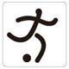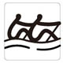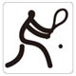

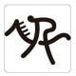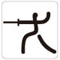

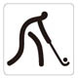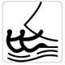
Diving
Football

Hockey

Sailing
Rowing
Cycling

Archery
Tennis
Equestrian

Fencing

Can you match these Beijing Olympic Pictograms to their sport?

Choose 3 of your favourite sports and invent a pictogram for each. Remember it must be made up of clear, distinct lines – NOT a normal picture.

