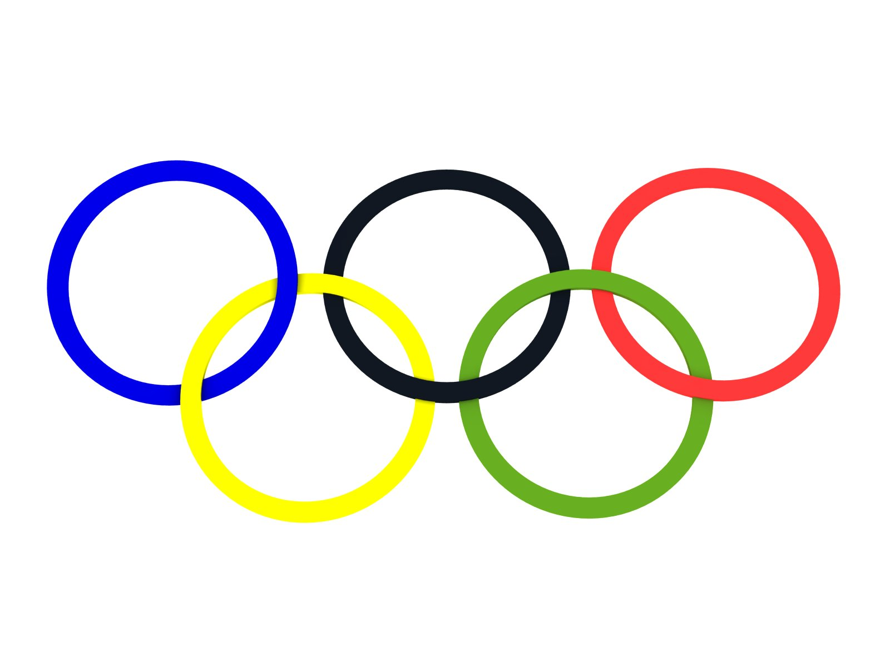
10 |  |  | 
9 |  |  |  |  |  |  | 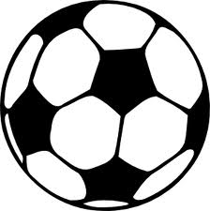
8
7 |  |  |  |  |  | 
6
5
4 |  | 
3
2
1 |  |  |  |  | 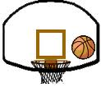
 | A | B | C | D | E | F | G
Olympic Co-ordinates
Can you find the co-ordinates of these Olympic sports?
=

=

=

=

=

=
Olympic Co-ordinates
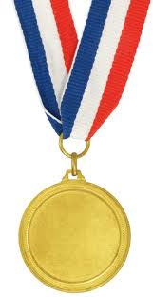

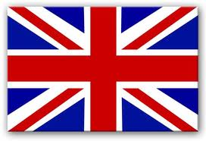
10
9
8
7
6
5
4
3 |  |  |  |  | 2012
2
1
 | A | B | C | D | E | F | G
2012 = E3
= A8

= D10

= G1

= F7

= C5

= G9

= E8

= B1
Can you draw these Olympic symbols into the correct grid squares?

