SHEPHERDS WEEKLY
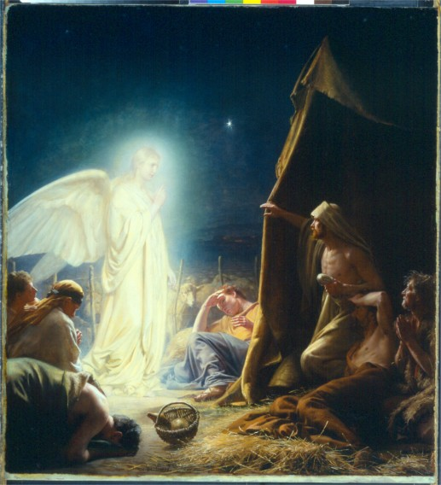
By All Saints’ Year Four
While shepherds watched their flocks by night, an amazing angel came and spoke to the shivering sheep minders.

The sleepy shepherds could hardly believe their eyes and ears when they were awoken late last night by a loud bang followed by a bright light in the sky.

“At first I thought it was a huge thunder storm!” exclaimed one excited shepherd. “But as I looked up, I saw an awesome apparition!”

Apparently, the angel told the sheep watchers some very good news… That Jesus Christ, a Saviour to all mankind, was born in Bethlehem.

The shepherds immediately had to leave their shocked sheep to go and investigate in the town.
“We followed a star to a cozy cattle shed where the holy infant was sleeping in a manger!” recalled John, one of the shepherds, “It was exactly as the angel had told us!”

The shepherds are now determined to go and tell as many people as possible. “This is good news and we can’t just keep it to ourselves! We must go and tell everyone immediately!”

25th December Still only £1.00!
AMAZING ANGEL SPEAKS TO SHEPHERD!
The angel of the Lord came down!
Now on in a town near you… The first Christmas ever!
Superb, sharp sheep shearers! Buy one - get one free! CALL 0800 777 777

