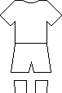
Name: Date:
World Cup 2010 strips
Use the internet or world cup magazines/books/posters to find the strips for each team in the 2010 World Cup. Colour and label each one(You will need 2 sheets)
http://www.fifa.com/index.html

