World Cup Tickets
Royal Bafokeng Stadium USA v England 12th June
An adult ticket for seating section 1 costs £160 each
An adult ticket for seating section 2 costs £132 each

An adult ticket for seating section 3 costs £120
An adult ticket for seating section 4 costs £140

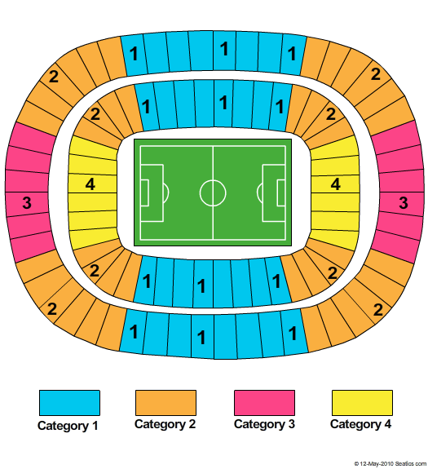

Children get tickets for half price
Students get 20% off the price of an adult ticket

Calculate the cost of:

1 | 2 adult tickets in section 2
2. | 3 adult tickets in section 4
3 | A child ticket in section 1
4 | 1 adult and 1 child ticket in section 3
5 | 2 adults and 2 children in section 2
6 | 2 adult tickets in section 2 and 2 adult ticket in section 3
7 | A student ticket in section 4
8 | An adult and student ticket in section 2
9 | 2 student and 1 child ticket in section 1
10 | 1 adult, 1 student and 2 child tickets in section 2

