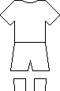
Name: Date:

Rugby World Cup 2011 Strips
Use the Internet or world cup magazines/books/posters to find the “home” strips for each team in the 2011 Rugby World Cup. Colour and label each one.

