***Words for describing what things look like***

C:\Documents and Settings\nharverson.GREVILLE\Local Settings\Temporary Internet Files\Content.IE5\GTJUMO60\MC900440450[1].WMF

Dull

* colourless
* drab
* faded
* pale

To look

* observe
* peek
* peer
* scan
* scrutinise
* spy
* squint
* stare
* view
* watch

Dirty

* filthy
* grimy
* grubby
* stained
* tarnished
* unclean

Smudged

* blurred
* smeared

Sparkling

* flickering
* glimmering
* glinting
* glittering
* glistening
* shimmering
* twinkling

hair

* blond
* brunette
* auburn
* bleached

Bright

* blazing
* brilliant
* dazzling
* glaring
* gleaming
* glowing
* light
* radiant

Dark

* dim
* dingy
* dull
* gloomy
* murky

Clear

* crystal clear
* transparent
* see through
* invisible

Misty

* foggy
* cloudy
* hazy

Speckled

* dappled
* freckled
* mottled
* splotched

Shiny

* glistening
* glossy
* polished
* reflecting
* sheen

Coloured

* tinted
* tinged
* dyed

Worn

* faded
* ragged
* torn
* frayed
* Shabby
* tattered

Ugly

* unattractive
* hideous
* repulsive

Beautiful

* attractive
* pretty
* stunning
* gorgeous

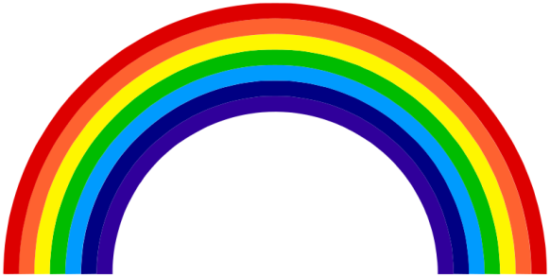**Words for colours**

**Black**

* charcoal
* coal black
* ebony
* jet black
* soot

**Purple**

* violet
* mauve
* amethyst
* lavender
* magenta

**Orange**

* tangerine
* auburn
* coral
* peach
* apricot

**Yellow**

* gold
* amber
* saffron
* lemon
* buttercup
* mustard

**Red**

* burgundy
* cherry
* crimson
* maroon
* rose
* ruby
* scarlet

**Blue**

* azure
* cyan
* navy
* sapphire
* sky blue
* royal blue
* teal
* turquoise
* ultramarine

**Green**

* emerald
* jade
* lime
* turquoise
* apple green
* aquamarine
* olive
* khaki

***Words for describing what things feel like***

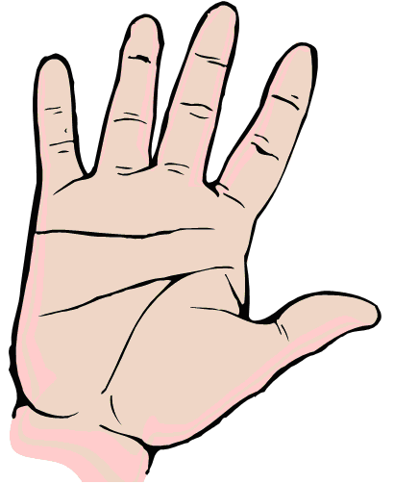

Sharp

* prickly
* thorny
* barbed
* jagged
* pointed
* razor
* serrated
* splintered

Wet

* damp
* drenched
* dripping
* moist
* soaked
* Soggy

Dry

* arid
* desiccated
* crisp
* parched

Rough

* bumpy
* bristly
* coarse
* lumpy
* gnarled
* textured

Soft

* comfy
* downy
* feathery
* fluffy
* furry
* spongy
* springy
* squashy

Cold

* freezing
* bitter
* chilly
* cool
* frosty
* frozen
* icy

Hot

* warm
* baking
* blazing
* blistering
* boiling
* burning
* fiery
* flaming
* parching
* piping
* sizzling
* steaming
* scorching
* sweltering
* searing

Smooth

* flat
* silky
* velvety
* glassy
* polished

Slippery

* oily
* greasy
* slimy

Hard

* firm
* solid
* tough
* stiff
* rigid
* strong

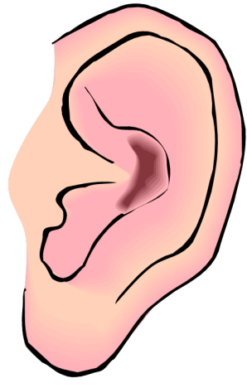***Words for describing sounds***

Shout

* bellow
* boom
* cheer

Bang

* blast
* clang
* clank
* crash
* crunch
* knock
* pop
* slam
* thud
* thump

Other sounds

* clink – of a glass
* crackle
* creak – a door
* echo
* fizz
* grunt
* gurgle - liquid
* honk - a horn
* hush – quiet
* jangle - keys
* jingle

patter - rain

* plunk
* racket
* rasp
* rattle
* ripple
* rumble
* rustle
* sizzle
* smack
* snarl
* snort
* splash
* swish
* tap
* toot

Scream

* screech
* shriek

Animals

* bark - dog
* buzz - bees
* cheep - bird
* chirp - bird
* croak – frog
* drone - bees
* growl - dog
* hiss - snake
* hoot - owl
* howl - dog
* meow - cat
* moo - cow
* purr - cat
* quack - duck
* roar – lion

Moan

* groan
* grumble
* rant

Talk quietly

* mumble
* murmur
* mutter

Sing

* chant
* hum

Laugh

* chuckle
* chortle
* giggle

Cry

* bawl
* blubber
* squeal
* wail

Talk

* chatter
* hubbub

***Words for describing smells***

Nouns

* aroma
* fragrance
* odour
* perfume
* reek
* scent
* stench
* stink
* whiff

Adjectives

* musty
* pungent
* putrid
* rancid
* rank
* spicy

C:\Documents and Settings\Neil\Local Settings\Temporary Internet Files\Content.IE5\XPPY2VLQ\MC900434387[1].wmf

***Words for describing how things taste***

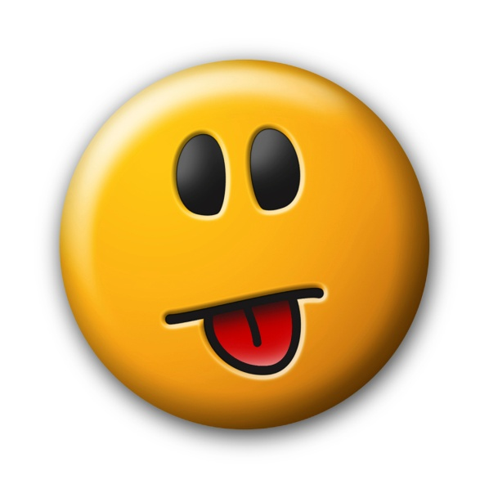

* peppery
* salty
* sharp
* sour
* spicy
* sugary
* sweet
* tangy
* tasteless
* acidic
* appetising
* bitter
* bland
* delicious
* flavoursome
* gingery
* honey
* insipid
* mellow