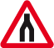  start |  | 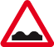 | 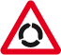
Dual carriage way ends.  Where is give way? | Where is risk of ice? | Where is no left turn? | Where is the sign tram crossing ahead?
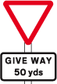 | 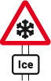 | 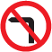 | 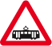
Where is cross roads? | Where is no cycling? | Where is no U-turn? | Where is slippery road?
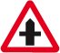 | 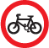 |  | 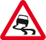
Where is tunnel ahead? | Where is no right turn? | Where is mini roundabout? | Where is steep hill downwards?
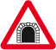 |  |  | 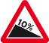
Where is level crossing without Barrier or gate? | Where is one way traffic sign? | Where is the loose chippings sign? | Where is zebra crossing?
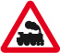 |  | 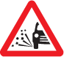 | 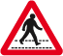
Where is the cattle sign? | Where is maximum speed? | Where is no overtaking? | Where is the stop sign?
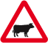 | 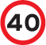 | 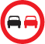
Where is level crossing without a barrier? | Where is uneven road? | Where is roundabout? | Stop

