5 Creative
Design Ideas

If you have a spare hour or so with a class, or are a relief teacher left to teach a class with no planning, try one of these activities.
They all involve class discussion first and I recommend displaying a set of criteria you expect to find on their designs. I have tried and tested all of these design activities and found them all to highly stimulate and motivate the students, bringing out amazing creativity. They are most suited to years 4-6. There is a Colour Representation Sheet at the end that students could refer to.

Design Task 1: Design a Treehouse
Design Task 2: Design your Dream School (this works successfully as a paired activity with pairs presenting their designs to the class afterwards)
Design Task 3: Design a new School Uniform
Design Task 4: Design your Family Flag
Design Task 5: Advertise your Street (students could have the option of basing this on an imaginary street)

Design a Treehouse!
Doesn’t every child want a treehouse?

What would your dream treehouse include?

How would you enter and exit it?

What would be inside it?

Think of the materials needed, how it would stay secure and how to make it waterproof.

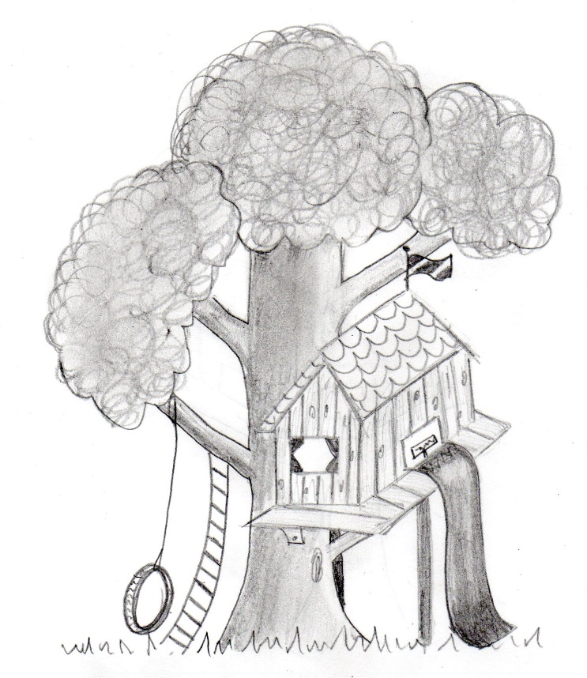
Design your
DREAM SCHOOL!

- Your school has to be functional!

- Students will learn there, but how they learn is up to you.

- Think of what will be on the school premises, including the classroom designs, eating facilities, sport facilities …

Use your imagination to create
a school that would be like
paradise!
Design a new
School Uniform

What would look cool to wear and yet be practical and suitable for school?

Choose the colours carefully and consider little details such as pockets and fastenings.

Which materials would your uniform be made from?

Don’t forget to include the school name and logo.

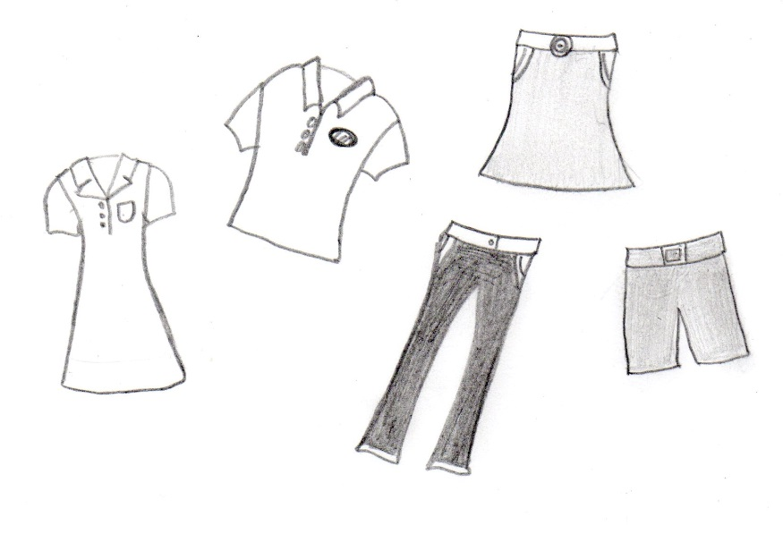

Design your Family Flag!

What is important to your family?
Which symbols should be on there to represent what is important to your whole family?
Think carefully about the colours you choose.
Include interests of all members of your family and make sure it is a fair representation of you all.

MAKE IT A FLAG YOU WOULD BE PROUD TO DISPLAY!

ADVERTISE YOUR STREET!

Why would people like to live on your street?
What makes it better than other streets?

- Think of a catchy slogan to go on your advertisement
- Use capital letters effectively
- Use persuasive language and clear illustrations
- Look at your advert and think ‘Would I like to live there?’

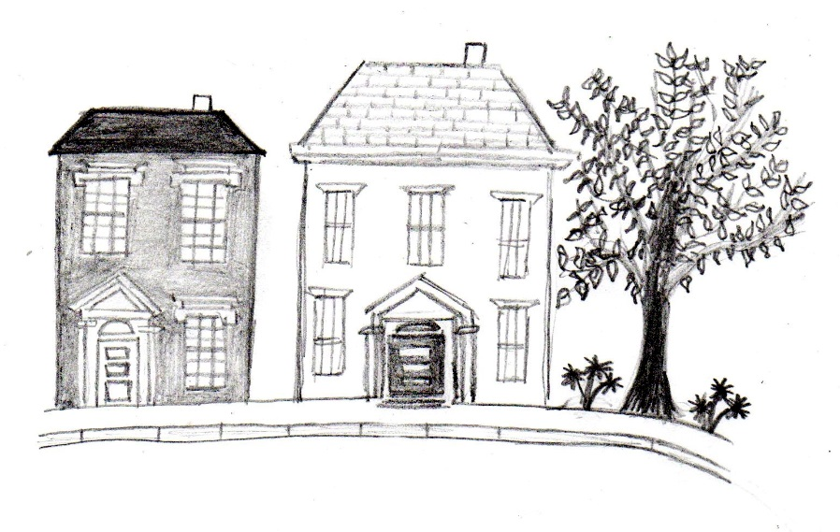

Colour Representations

Red: energy, strength, love and danger
Pink: romance, love and femineity
Orange: confidence, happiness and success
Yellow: joy, happiness and energy
Green: harmony, freshness, jealousy and growth
Black: drama and evil
Blue: tranquillity, trust and calm
Brown: outdoors, friendliness and simplicity
Gold: wealth, value, greed and extravagance
Grey: intelligence and sadness
Purple: royalty, luxury and creativity
White: innocence, purity and cleanliness

