Fairground Rides

Uplands Junior School
Year 5
Name:___________________________

I can design and make a model of a fairground ride in which an electric motor produces rotating movement.

Investigating Pulley Systems.

Before the fairground ride can be made, it is important to understand the mechanics of rotational movement using pulleys and drive belts.

Using 2 pulley wheels and an elastic band as the drive belt, follow the diagrams below to see how the direction of rotation of the pulley changes when the drive belt is twisted.

drive

Card disc (pulley wheel - A)
belt

Motor (B)

Set up the above diagram to see whether A or B rotate at different speeds.
You should find that the small pulley (B) rotates much more quickly than the large pulley (A) but has less turning force (torque).

slow
standard

very fast

Pulley wheels connected in a pulley train can be used to give a greater increase or decrease in speed.
Choose between a Ferris wheel and a Carousel

Think about the ride you want to make. Draw a picture of how you want your ride to look once it has been completed. Think about the colour scheme you may want. If it is a carousel then think about what type of animals you want as part of your ride. If it is a Ferris wheel think about colouring of seats, size of the seats and number of seats. Label your diagram.

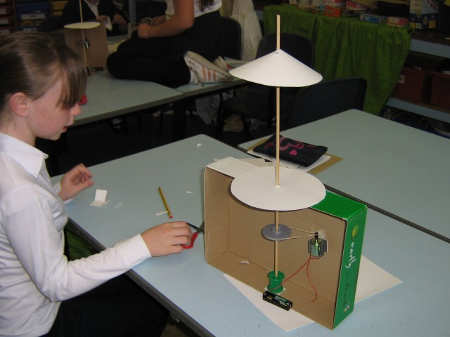
This image should help you to gain ideas about how you can get your ride to move using an electric motor. Draw arrows and label the following: motor, spindle (dowel), battery/cell, electrical wire, pulley wheel and drive belt. Which way do you think the spindle is going to turn? Is this in the horizontal plane? How could we adapt the cardboard frame to make the spindle turn in the vertical plane? How can we attach the motor to the frame? Think about the force acting on the motor from the drive belt - if the belt is too strong will it pull the motor off the frame? Does the drive belt (elastic band) need to be taut? What would happen if the belt/elastic band was too slack? Look at the spindle. Would the constant turning of the spindle cause frictional damage on the cardboard frame? How could we over come this?
Once the class has considered these questions you can move onto Step 1.

Step 1 - I can make a framework that contains moving parts made from an electric circuit connected to a motor, which in turn is connected to a pulley wheel and drive belt.

Equipment List:

_________________ _______________

_________________ _______________

_________________ _______________

_________________ _______________

A photograph of my initial frame for the fairground ride

My instructions for completing Step 1.

First I___________________________________________________________________________

Then I___________________________________________________________________________

Next I___________________________________________________________________________

After that I_______________________________________________________________________

Following this I___________________________________________________________________

________________________________________________________________________________

Finally I_________________________________________________________________________

Step 2
I now have a moving part for my ride so I am going to construct the actual ride. (Not forgetting to decorate sections of my ride before assembling it).

Equipment: (I must consider what I want my ride to be made from - lolly pop sticks, cardboard, paper)

_________________ _________________ _________________

_________________ _________________ _________________

_________________ _________________ _________________

_________________ _________________ _________________

My design for a fairground ride. A photograph of my ride so far.

The problems I have encountered here include:

___________________________________________________________________________________

___________________________________________________________________________________

___________________________________________________________________________________

___________________________________________________________________________________

What I enjoyed the most about this stage of my model making include:

___________________________________________________________________________________

___________________________________________________________________________________

___________________________________________________________________________________

___________________________________________________________________________________

___________________________________________________________________________________

Continuation of Step 2

Write a diary extract about what you have achieved so far with your model making (remember to put information into your diary about who you are working with and any problems you have encountered and what you have enjoyed so far about this project).

_________________________________________________________________________________

_________________________________________________________________________________

_________________________________________________________________________________

_________________________________________________________________________________

_________________________________________________________________________________

_________________________________________________________________________________

_________________________________________________________________________________

_________________________________________________________________________________

_________________________________________________________________________________

_________________________________________________________________________________

_________________________________________________________________________________

_________________________________________________________________________________

_________________________________________________________________________________

_________________________________________________________________________________

_________________________________________________________________________________

_________________________________________________________________________________

_________________________________________________________________________________

_________________________________________________________________________________

_________________________________________________________________________________

_________________________________________________________________________________

_________________________________________________________________________________

_________________________________________________________________________________

_________________________________________________________________________________

_________________________________________________________________________________

_________________________________________________________________________________

My Model Fairground Ride

My completed ride

Extension Activity

Can you use a computer and interface connection to get your ride to work?

Evaluation of my work: (Questions to think about: Did you enjoy the task? Did you come across a lot of problems, would you do anything different next time? Can you make improvements to your ride?)

___________________________________________________________________________

___________________________________________________________________________

___________________________________________________________________________

___________________________________________________________________________

___________________________________________________________________________

___________________________________________________________________________

___________________________________________________________________________
Useful Keywords

Electric motorPulley wheels

Spindle (dowel)pulley train

Crocodile leadscard disc

Electric wireframework

Cotton reelsvertical plane

Drive belts (elastic bands)horizontal plane

Rotationdesign

Modelcomputer interface

Improvementsevaluate

