DT: My Moving Monster Date_________

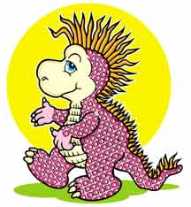
My moving monster looked like this….

The materials I used were…

To make my monster move I used a type of ______ _______

This is how it worked…

