Teacher’s Notes

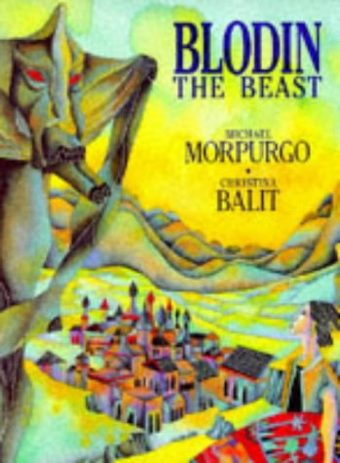

- Introduce book, look at cover/ title/ blurb/ author etc..

- Read the 1st page, using the text and pictures describe Blodin and how the people fell about him. Writing Challenge: write your own description of Blodin using powerful verbs and adjectives, try to use a simile too.

- Read the next 2 pages, why does Old Shanga want to stay? Why do you think Hosea says that he will stay with him? What do you think he means by “there is more than wool in this carpet.”?

- Read the next 3 pages, how do you think Hosea is feeling? Does he know what he’s got to do? How do you think the carpet will help him? Writing Challenge: imagine you are Hosea and you have a diary, write an entry in you diary to say how you are feeling at this particular moment.

- Read the next 3 pages. Look at the illustration of the forest then the desert, discuss the use of colour and how they differ. How do the pictures help the text to aid the reader’s imagination? What do you think has happened to old Shanga at the end of this section? Why?

- Read the next 2 pages, how do they make you feel? How does the author create a sense of excitement and fear? Finish the book. How do you think Hosea feels at the end of the story…. sad because he knows Shanga is dead? Happy because he’s killed Blodin? Relieved? Grateful? Writing Challenge: write another diary entry as Hosea, expressing your feelings at the end of the book.

- Find your favourite illustration from the book, write about it saying why you think it’s so good.

- Find out more about Michael Morpurgo, look at his website,
www.michaelmorpurgo.com/

- Try to reproduce on of the illustrations using pen and ink or water colours.

- Use the Internet to find out more about the illustrator Christina Balit, who is she? Has she illustrated any other books?

