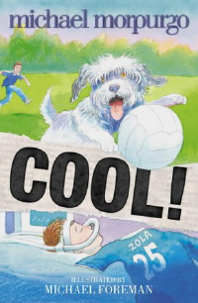

- Predict content of a book by it’s cover and blurb.
Discuss familiar authors and express preferences.
Look at front cover and read blurb, what it the story going to be about. This could also open up a discussion about whether stories have to have a happy ending, (this one does) to be good. Discuss author, does anyone know any other books, like/dislike any of his other work?

- Discuss characters and their motives
Read 1st Chapter (ensure that children read newspaper cuttings at the start/end of each Chapter,) who are the main characters in this story? What do we know about them so far? Discuss. Children to complete brief description in note form of each character that has been introduced so far.

- Use punctuation to follow meaning and to read aloud with expression and fluency.
Discuss skills for reading aloud, what punctuation marks mean, how we use them in reading aloud, phrasing etc… Read Chapter 2 taking turns to read aloud and evaluate performance. Discuss Chapter.

- Identify the point of view from which a story is told and understand how this affects the readers’ response.
Read Chapter 3, establish that the story is told from Robbie’s point of view so we get to hear all Robbie’s thoughts and feelings. How does Robbie feel about Mr McAllister? How does he make us feel we feel about Mr McAllister? If the story was told from Mr McAllister’s point of view how would it differ? Would we feel differently towards Robbie? How and why?

- Understand how authors can convey the passing of time in stories; keep track of time passing.
Read Chapter 4, all the way through the story Robbie is confused about how long he’s been in a coma, how does the author keep us informed about the passing of time? Go back and look at the newspaper articles, these are the main way in which the passing of time is indicated, re-read and establish how much time has passed for each chapter.

- Investigate how authors build suspense
Read Chapter 5, how does this chapter make us feel and why? O we want to read on, how has the author employed suspense to make us want to read on?

- Evaluate books read expressing likes and dislikes
Finish book, discuss and complete Book Review sheet.

