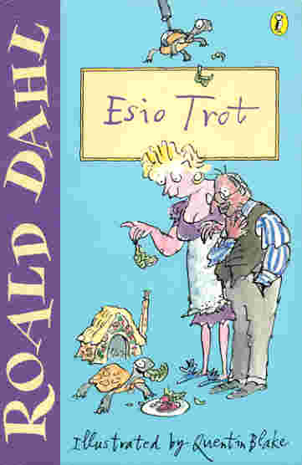
Esio Trot
Teacher's
Notes

by Roald Dahl

- Discuss authors and express preferences.
Discuss Roald Dahl, what other stories do the children know? Do they like/ dislike his writing? Why? What do they think makes a good author?

- Read author’s note at front of the book and discuss. Extra task- what else can the children find out about tortoises?

- Investigate how authors build up their characters by description of their actions and what they say as well as physical description.
Read P3/4 what do these pages tell us about Mr Hoppy? Find examples in the text which describe Mr Hoppy, and actions which tell us about his character. Write your own description of Mr Hopppy from what we know so far.

- Discuss motives of characters using evidence from text.
Make predictions about what could happen next.
Read to P14, what do you think Mr Hoppy is going to do? How do we feel about/ for his character?

- Use punctuation to follow meaning and to read aloud with expression and fluency.
Discuss skills for reading aloud, what punctuation marks mean, how we use them in reading aloud, phrasing etc… Read to P25 taking turns to read aloud and evaluate performance.

- Discuss motives of characters using evidence from text.
Make predictions about what could happen next.
Read to P 43 and discuss text; Was Mr Hoppy doing the right thing? What might Mrs Silver do if she finds out the truth?

- Evaluate books read expressing likes and dislikes
Finish book, discuss and complete book review.

