Saint George
and the
Dragon
Teacher’s Notes

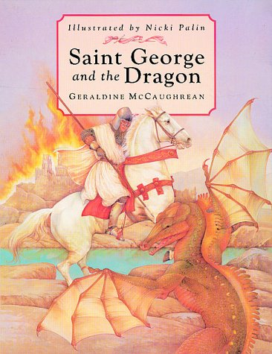

- Introduce book, look at cover/ title/ blurb/ author etc..

- Read first 3 pages and look at the illustrations. Find all the sentences that describe the dragon, check understanding of vocabulary. Look at use of powerful verbs and adjectives to describe the dragon. Writing Challenge: write your own description of the dragon trying to us powerful verbs and adjectives.

- Read next 2 pages, ask each member of the group to be one of the people in the illustration, what are they thinking? What would they say to the other people on the page? Can the children empathize with the characters’ feelings? What do you think is going to happen now the Princess Sabra’s name has been chosen? Writing challenge: write a conversation between 2 of the people on the page e.g. the soldier and the mother.

- Longer reading session: read the next 5 pages until “…the creature crashed down on to it’s side.” How does the author make the fight exciting? How does the illustrator make the fight exciting? How do the words and pictures make you feel? Writing Challenge: Can you think of 5 similes to describe the dragon, 5 to describe the Princess and 5 to describe George?

- Read to the end of the book. What did the children think of the story? Was it told in effective way? Why? Did they enjoy it or dislike it? Why? Writing Challenge: Choose a favourite page from the story, either because of it’s text, illustrations or both, write about why you like it.

- Create your own dragon, nice or nasty, write a description of it and illustrate your work.

- Find different versions of the story, compare the text and the illustrations.

- Look on the Internet at other artists’ impressions of St. George, how do they compare?

- Find out about the Patron Saints of Ireland, Scotland and Wales, who were they and what did they do?

- Examine how the Union Jack is made up.

