Silent Letters
Match the word to the picture.
Then highlight the silent letter(s).
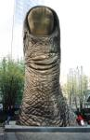
___________
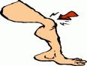
___________
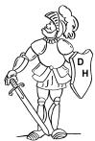
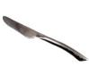
___________
___________

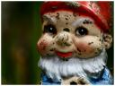
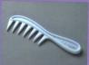
___________
___________

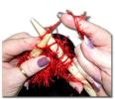
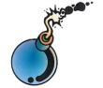
___________
___________

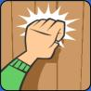
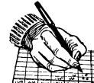
___________
___________

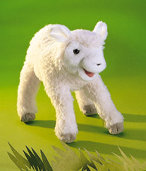
___________
write comb lamb knit knight knee gnome

bomb thumb knife knock

