Noun Anagrams

act  _____ | 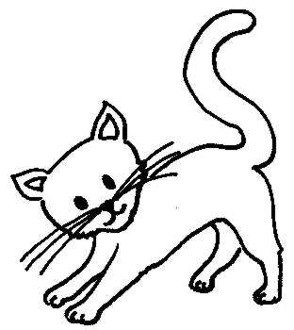 | usheo  _____ | 
wot  _____ | 2 | ether  _____ | 3
byab  _____ |  | veesn  _____ | 7
albl  _____ |  | ehgti  _____ | 8
lteab  _____ | 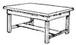 | gdo  _____ | 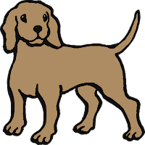
eno  _____ | 1 | ordo  _____ | 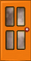
cairh  _____ |  | soen  _____ | 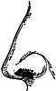
byo  _____ |  | nemoy  _____ | 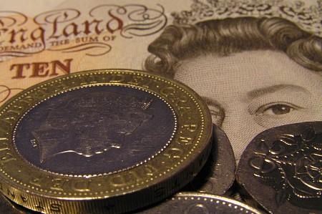
irgl  _____ |  | eesy  _____ | 
ebd  _____ |  | etfe  _____ | 