Silent Letters 1

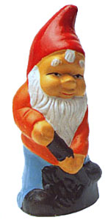  _nome | bom_ | _nife
lam_ | si_n | com_
  _rite | _nock | 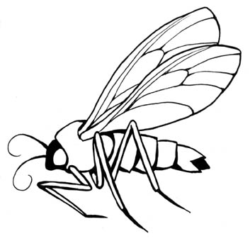  _nat
_nit | _not | thum_
_night | s_ord | w_ale
Silent Letters 2

Copy these words into your books and circle the silent letter in each one.

knuckle
wrestle
dumb
knee
honest
wrapper
kneel
answer
know
wrapper
numb
wrong
chemist
wrist
wrinkle
rhyme
wheat
when
crumb

